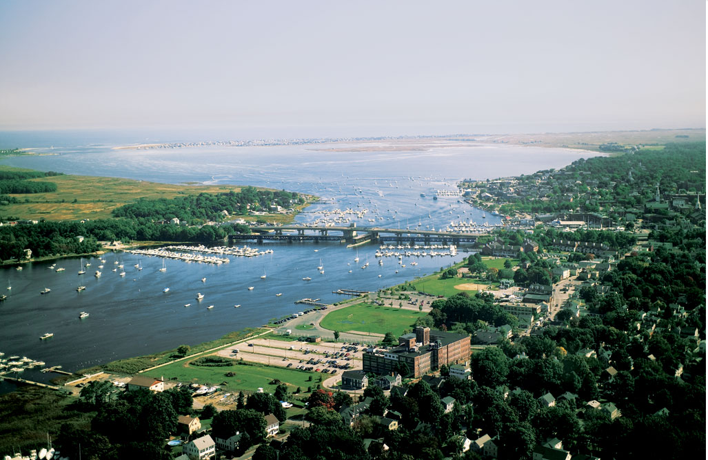
  - Flood Resilience for Riverine and Coastal Communities BUILDING BLOCKS FOR SUSTAINABLE COMMUNITIES

  - Newburyport, Massachusetts
  - Next Steps Memorandum

January 29, 2016

Photo credit: City of Newburyport, Massachusetts

INTRODUCTION
The core mission of U.S. Environmental Protection Agency (EPA) is to protect human health and the environment. EPA’s Office of Sustainable Communities (OSC)—or the Smart Growth Office— helps to support this mission by working with communities to reach development goals that create positive impacts on air, water, public health, economic vitality, and quality of life for residents. EPA Regional Offices also support these efforts. OSC created the Building Blocks for Sustainable Communities program to provide quick, targeted technical assistance on specific smart growth development topics by bringing subject matter experts to communities. Communities request this technical assistance through a competitive application process. For this technical assistance on Flood Resilience, the general goal is to help the community determine whether its current strategies foster flood resilience and consider additional strategies to reduce long-term risk from flooding and improve resilience.
The Building Blocks process is designed to move a community through a process of assessment, convening, and action planning—helping learn about a given topic and creating a plan to move forward on implementation. The program helps a community identify potential challenges, as well as realize opportunities to make progress. It includes a series of pre-and post-workshop conference calls, a self-assessment, and an on-site convening of stakeholders to discuss issues, next steps, and actions related to advancing the community’s specific goals. These efforts help a given community gain a deeper understanding of a particular smart growth issue and identify specific steps necessary to move them closer to implementation. The diagram below outlines the typical flow of the Building Blocks technical assistance program.
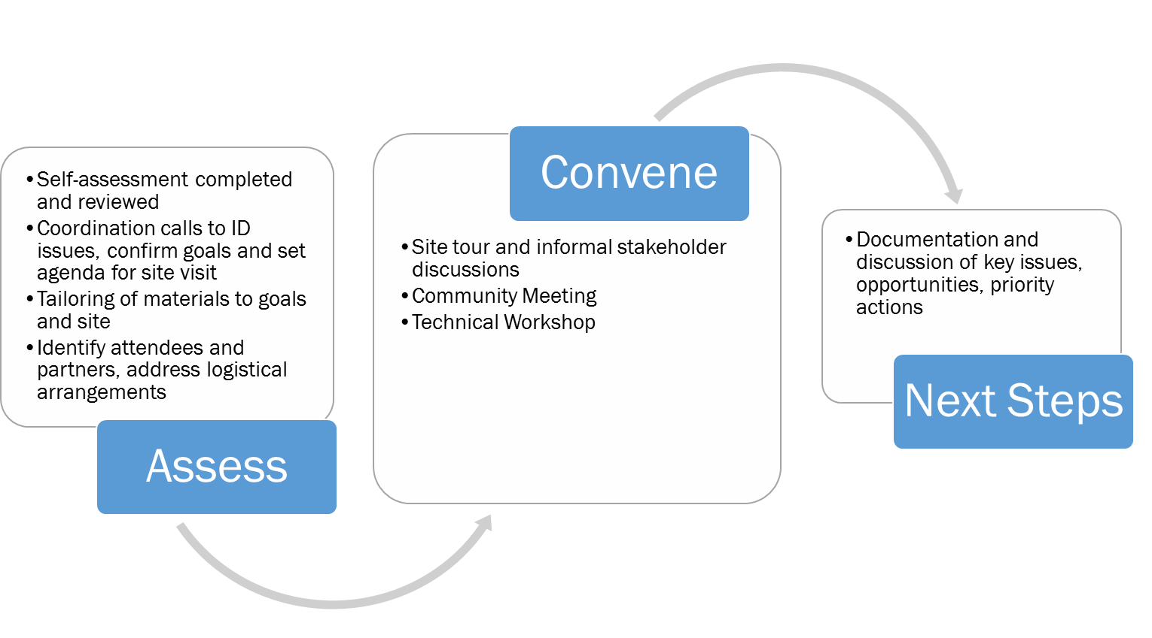
THREE STAGES OF TECHNICAL ASSISTANCE (CREDIT: RENAISSANCE PLANNING)
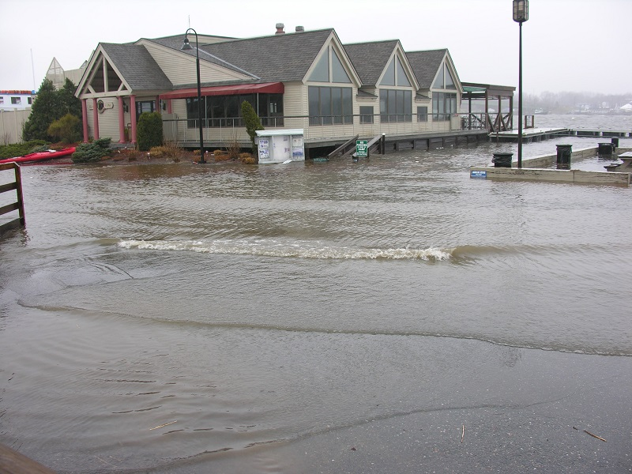
This memo documents the key outcomes of EPA’s technical assistance project for Newburyport, Massachusetts using EPA’s Flood Resilience for Riverine and Coastal Communities Tool. It identifies important community issues, prioritized goals, and specific actions to achieve Newburyport’s goals of: (1) protecting critical public infrastructure; (2) reducing flood risk in developed areas; (3) promoting stormwater management best practices in the business park containing manufacturing and service companies and elsewhere; (4) working across neighboring towns to address flood concerns; (5) creating a “flood smart” community; and (6) coordinating current and future flood and climate risk assessments.
RISING FLOOD WATERS AT THE CENTRAL WATERFRONT (CREDIT: CITY OF NEWBURYPORT)

COMMUNITY CONTEXT
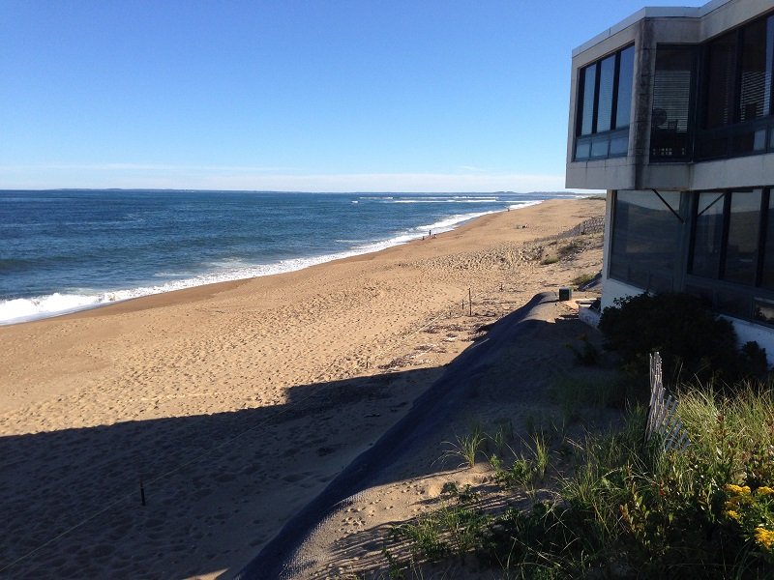
Newburyport is a small, coastal city, located northeast of Boston, at the mouth of the Merrimack River. The city’s coastline includes part of Plum Island: a heavily populated, eleven-mile barrier beach surrounded by the Great Marsh, Massachusetts’s most extensive estuary system. The city experiences coastal, riverine, and stormwater flooding in many areas, including the historic downtown and business park. In addition to the flood hazard, the city is faced with coastal erosion in and around Plum Island.
PLUM ISLAND AT THE END OF 55TH STREET (CREDIT: TETRA TECH)
During storm events, the city protects several pump stations, treatment plants, and roads from flooding. Historically, the city has protected the community with hardscape structures such as sea walls, riprap, groins, and timber revetments. These solutions have become difficult to maintain, especially as sea level rise, higher tides and frequent storm events have exacerbated inland and coastal flooding. The city is willing to consider different approaches to flood management including natural adaptability, low impact development, and green infrastructure solutions. Specifically, the city is interested in:
- Protecting their critical infrastructure including utilities from floods
- Understanding how to educate the community on flood preparedness
- Identifying stormwater management best practices to help lessen the impact of flooding in the business park
- Coordinating the efforts described above to prevent overlap and move forward in a focused direction
Several flood mitigation planning efforts are already underway in Newburyport. The Merrimack Valley Planning Commission (MVPC) is finalizing their Multi-Hazard Mitigation Plan to FEMA which will help the community identify risks and mitigation projects. The city also has a Stormwater Master Plan in place. The National Wildlife Federation (NWF) is using grant funding from the Department of Interior to implement five projects related to dune nourishment and native vegetation planting, native habitat restoration, hydrological barrier assessment and prioritization, hydrodynamic and sediment transport modeling, and coastal community resilience planning. With these projects, plans and a potential update to the city’s Master Plan in the next two years, there is opportunity to plan for and implement flood resiliency strategies in the short and long term.

SELF-ASSESSMENT
Prior to the onsite workshop, key Newburyport staff filled out a community self-assessment: a set of yes/no questions designed to help the community determine how its current strategies foster flood resilience. The checklist is also designed to help the community consider additional strategies to reduce long-term risk. The self-assessment was divided into five general categories, each of which focused on several strategies:
- Overall Approaches to Enhance Flood Resilience and Integrate it into Community Planning,
- Conserve Land and Discourage Development in River Corridors and Critical Coastal Areas,
- Reduce Risk to People, Buildings, and Facilities in Vulnerable Settlements,
- Plan for and Encourage Development in Safer Areas, and
- Implement Stormwater Management techniques throughout the Whole Watershed, including Coastal Areas.
Completing the self-assessment provided the local and project teams with initial insight on community strengths and opportunities for improvement.

COMMUNITY CONVENING
EPA contractor Tetra Tech, with support from EPA staff, led an on-site workshop in Newburyport on September 23 and 24, 2015. City staff helped to convene key stakeholders, and coordinated the workshop events.

Site Tour
On September 23, the project and local teams began by touring the flood-prone areas of Newburyport. In attendance were representatives from various city departments; representatives from EPA headquarters and EPA Region 1; staff members from the Federal Emergency Management Agency (FEMA) Region 1, National Oceanic and Atmospheric Administration (NOAA), the Army Corps of Engineers (USACE), Massachusetts Coastal Zone Management (CZM); and representatives of the National Wildlife Federation and Storm Surge. The tour visited several sites including (1) the historic downtown and riverfront, (2) critical water and wastewater utilities, (3) Plum Island, (4) the business park, (5) the salt marsh, (6) a vulnerable dam, and (7) the reservoir.
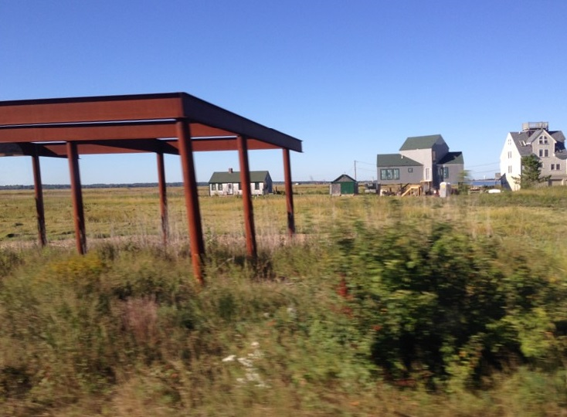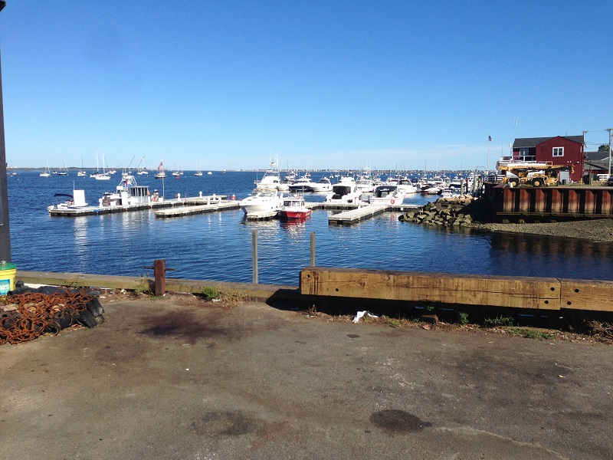
COASTAL DEVELOPMENT ALONG PLUM ISLAND TURNPIKE (CREDIT: TETRA TECH)
CENTRAL WATERFRONT ALONG THE RIVER (CREDIT: TETRA TECH)

Community Meeting
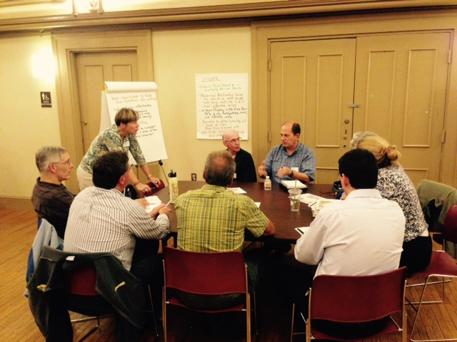
Following the tour on Day 1, the project team facilitated a community meeting to provide an overview of the topic of flood resilience in coastal communities, and hear from residents and stakeholders about primary challenges, strengths, and opportunities for enhancing flood resilience that they see in the region. Between 30 and 40 community members attended, in addition to federal, state, and local agencies, nonprofits, and civic groups. The project team provided maps depicting the 100-year floodplain, sea level rise, hurricane surges, and critical facilities. These maps (attached in the appendix of this document) helped communicate risk to residents and helped facilitate about community members’ concerns. After a PowerPoint presentation describing the technical assistance process and a review of the community’s self-assessment of its current flood resilience, attendees divided into several groups and were asked to provide feedback on the most important local issues based on their experiences, using the maps to help stimulate discussion.
GROUP DISCUSSING LOCAL FLOOD ISSUES (CREDIT: TETRA TECH)

Technical Workshop
Day 2 included a morning work, which focused on exploring specific options for addressing local flood resilience issues. This session was followed by an afternoon work session, which focused on engaging key stakeholders, technical staff, and elected officials to identify steps they could take to move forward with some of the ideas discussed in the morning session. Over 30 people participated in the technical workshop. The participants are identified in the appendix of this memo.

KEY COMMUNITY ISSUES
Newburyport has been working to address coastal risks for several decades. The most pressing issues have been how to address infill development, protecting vulnerable infrastructure, sea level rise, coastal erosion around the jetty, and flooding in the business park. As the residents have become increasingly aware of the vulnerabilities associated with projected sea level rise and increased frequency and severity of storms, the town is investing in its ability to address challenges, leverage its strengths, and capitalize upon the opportunities that exist to improve its resilience, in both the short and long term.

Strengths
The town has a number of strengths that will contribute toward its pursuit of flood resilience. Many of the strengths relate to its people and its position as a long-standing, established community.
- Leadership from local officials and engaged citizenry: The mayor, some of the city’s senior leadership, neighbor community (Newbury) members, and key citizen groups attended both workshops and engaged with other participants, showing their commitment to building increased flood resilience in the city.
- Willingness to adapt: The city is at a critical point in time where they can either maintain traditional forms of development in hazard risk zones, hoping major storm events miss them, or update ordinances and integrate mitigation projects into new development projects, proactively reducing flood risks. They city’s participation in this technical assistance shows a clear desire for the latter.
- Existing plans, ordinances, and regulations: Local Open Space and Recreation Plan, Open Space Residential Overlay District, Hazard Mitigation Plan, the Estuary Management Plan, and the Stormwater Management Ordinance, participation in the NFIP, and the Local Citywide Wetlands Protection Ordinance and Regulations.
- National Wildlife Federation resilience projects: With funding from the Hurricane Sandy Grant, the National Wildlife Federation is currently studying and evaluating sea level rise and climate change impacts to the Great Marsh and communities within. The results of this $3M grant work will be complete in late 2016. The analysis, strategy implementation, data and model development, and community outreach are a good stepping-stone for future work, and can be incorporated into the city’s planning efforts.

Challenges
Newburyport’s flood risk challenges are increasingly associated with climate change, stormwater management, and critical infrastructure that is located in recurrent flood zones.
- Coastal flood risk: Plum Island is a barrier island that has been built up by the action of waves, currents, and winds and which protects the shore from the ocean. This constantly changing island has been developed with residential homes, and much of the protective sand dune on the island has eroded, causing the shoreline to creep inland. While the shoreline moves, however, the buildings remain in the same location, without the natural barriers that once protected them. In addition, sea level is rising, and the rate of this rise is accelerating. Sea level rise, in combination with storm surge, presents serious challenges for coastal homeowners.
- Exposed critical assets: Several critical assets are located in the 1% annual chance floodplain (the area that will be inundated by the flood event having a 1-percent chance of being equaled or exceeded in any given year). These utilities include pump stations, a wastewater treatment plant, reservoir, electric plant, and several roadways connecting different parts of the community, including an evacuation route from Plum Island.
- Antiquated stormwater management systems: Some areas of the community, including the business park, experience frequent flooding from stormwater due to their lower elevation. Businesses sometimes operate with several inches of water in their facilities and some have elevated utility systems to minimize flood impacts. Swales, low tracts of land that are usually moist with rank vegetation, are maintained inconsistently, and other mitigation strategies could provide additional benefits. Although low-lying areas are affected the most, workshop participants indicated that stormwater management is a top priority for the entire community.
- Coordination: There are several projects and planning processes going on currently and in the near future: NWF project, hazard mitigation plan, comprehensive plan, erosion studies, stormwater projects, and upstream projects in Newbury. These projects and plans have overlapping geographic areas and objectives but are not always coordinated.

Opportunities
Some opportunities for increasing flood resilience in the city include ongoing community planning activities, potential state and federal grants, and starting a dialog with the neighboring town of Newbury.
- Ongoing planning efforts/new updates: The Merrimack Valley Planning Commission is currently updating the city’s hazard mitigation plan and the NWF projects are moving forward which could be aligned and build off each other. As the city’s comprehensive planning and capital expenditure documents are updated, a process that is underway now, they can also be better aligned with the hazard mitigation plan. The public safety component of the comprehensive plan could borrow from the risk assessment in the mitigation plan.
- State and federal grants: There are federal grants (e.g., FEMA, NOAA, and USACE) that could support resilience efforts in the town. There is CZM grant funding available each year, which could fund public education and awareness; vulnerability and risk assessments; identifying and implementing management measures, standards, or policies; and redesigning to accommodate changing conditions.
- Partnerships with neighboring jurisdictions: Several representatives from neighboring jurisdictions, including Newbury, attended the flood resilience workshop and expressed interest in working together to address flood risks. This willingness to collaborate presents an opportunity for collaboration and joint funding of future flood resilience projects.
- Stormwater Utility: Newburyport has for many years considered implementing a stormwater utility, and has hired a consultant to make recommendations in this area. Whether it is through a stormwater utility or an increase in taxes, financial resources are necessary to build and maintain stormwater projects in many parts of the community, and a stormwater utility could help provide such funds.

NEXT STEPS
In the course of the technical workshops, the project team posed questions to the participants designed to foster discussions and draw out community members’ observations and opinions about strengths, weaknesses, and opportunities, summarized in the section above. The project team considered this feedback, and helped participants to develop a set of six goals with next steps for Newburyport. The workshop participants agreed that these goals were a good starting point for organizing actions and developing strategies to promote flood resilience.
To help achieve these goals, the city could hire a Resiliency Coordinator and create a task force focusing on creating and implementing a Resiliency Plan. Some jurisdictions work with their neighbors to help fund this coordinator position and others make it a part-time position. The steps identified in this report could be integrated into such a plan.
EPA New England is launching an online searchable database called RAINE (Resilience and Adaptation in New England) which collects information, and connects to resources, (specific documents, websites, presentations) on what towns, regional groups and states are doing to be more resilient and adapt to climate change. Example projects relevant to Newburyport include:

Salem, MA
- Green Infrastructure Feasibility Assessment
- Climate Adaptation Plan with list of climate change adaptation strategies
Manchester, MA
- Culvert and Green Infrastructure Analysis
Hull, MA
- Coastal Resilience Officer Position
- Climate Change Vulnerability Assessment and Adaptation Planning
Durham, NH
- Master Plan that incorporates Climate Change
Bangor, ME
- Stormwater Utility
Northampton, MA
- Stormwater and Flood Control Utility
- Multi- hazard Mitigation Plan that incorporates Climate Change
- Switch to using 500-year floodplain, not 100-year
Martha’s Vineyard, MA
- Visualizations of Sea Level Rise, Presentations
- Switch to using 25-year storm as design storm, not 10-year
Portsmouth, NH
- Listening Circles, high water marks

Protect critical public infrastructure
Newburyport has several utilities and transportation routes in the floodplain along the Merrimack River and on Plum Island. To qualify to apply for FEMA hazard mitigation funding, these resources must be identified in the hazard mitigation plan, which the Merrimack Valley Planning Commission is currently finalizing. There are three primary ways to deal with risks to critical infrastructure: (1) armor or elevate with minimal impact to the floodplain, (2) removed to a safer location, or (3) have critical components elevated. To determine what works best, the community could evaluate the areas that are at risk and decide what makes the most sense and how much it costs. Then the community must also figure how they’re going to pay for these changes, and come up with a funding plan. The No Adverse Impact (NAI) toolkit provides examples of flood mitigation, which could be implemented:
Supporting Implementation Steps | Why is this important? | Timeframe | Lead Role | Support | Cost & Implementation Resources
Include projects in hazard mitigation | Grant funding eligibility | Short (HMP), 1 year (CIP) | City engineer | Hazard mitigation committee | Staff time
Include projects in city’s Capital Improvement Plans | Allocate funding for mitigation | Mid to long term | City engineer | City Council, Water & Sewer Commission | Staff time
Consider applying for hazard mitigation grant funding | Ability to address hazards | November (deadline for HMGP) | City engineer and city grant writer |  | Staff time
Review NWF report on barriers to stormwater flow and act on high-priority recommendations | Build on existing activities and move forward with actions | Feb. 2016 (prelim. report) | Conservation administrator and DPS | NWF | Staff time and infrastructure costs
Identify vulnerabilities and prioritize drinking water/wastewater upgrades; repair seawalls | Risk under-standing and mitigation | Drinking water (med.), wastewater (long) | Engineering and utility directors |  | Staff time and infrastructure costs
Determine eligibility and apply for CZM grant funds | Mitigation implementation | FY2016 | City engineer and parks administration | CZM | Staff time

Reduce flood risk for future development
It is easier to integrate flood risk reduction strategies into new development than it is to attempt retrofits in existing development. Newburyport could help to communicate potential risk to developers and homeowners before they move forward with a project. They could require that a developer review stormwater and flood mitigation strategies and implement best practices when they initiate a project including no adverse impact to the floodplain. Examples of these best practices are: restricting damage-prone development, low density zoning, dry floodproofing, wet floodproofing, foundation protection (placement, compaction and protection of fill when used for elevation), limit enclosures below Base Flood Elevation (BFE), require non-supporting break-away walls in coastal areas, lower threshold for substantial improvements to less than 50%, or count improvements cumulatively so that the total value of all improvements or repairs exceeding 50% must meet current requirements. Other communities in Massachusetts where local building codes can’t be more restrictive than state building codes have reduced building application fees if structures are built to better standards. The city could also consider applying to FEMA to participate in the Community Rating System (CRS) to help residents and other property owners lower their flood insurance premiums. Many of the actions described in this memo, including the EPA Building Blocks Workshop, can be used for CRS credit.
Supporting Implementation Steps | Why is this important? | Timeframe | Lead Role | Support | Cost & Implementation Resources
Require flood mitigation for new development on the waterfront and other parts of the city | Reduce flood risk of coastal development | Medium | City planner | City Engineer | Staff time
Investigate participating in FEMA’s Community Rating System (CRS) | Reduce flood insurance premiums | Short (this year) Investigate potential with CZM and other supporting agencies | Mayor’s office | MA CZM, FEMA Region 1’s CRS Coordinator, State Floodplain Manager | Staff time
Communicate risk to individual property owners and developers before they begin a project | Raises awareness and educates residents | Medium (2-3 years) | City engineer | NWF (report) | Staff time and outreach materials

Promote stormwater management best practices in the business park
Property owners and tenants in the business park have shown a willingness to apply flood mitigation strategies, and even self-fund some stormwater maintenance. These efforts could be expanded to include actions such as onsite stormwater management, tree plantings, and water harvesting strategies. Areas located higher in the watershed are contributing to stormwater flooding issues, and property owners in those areas could be made aware of best practices that they can follow to minimize their impact on adjacent neighborhoods. Newbury experiences similar challenges, and could coordinate on joint projects that would benefit both communities. The Business Park and Chamber of Commerce could help businesses in the business park prepare continuity of operations plans.
Supporting Implementation Steps | Why is this important? | Timeframe | Lead Role | Support | Cost & Implementation Resources
Develop a stormwater utility with incentives for best practices related to flood mitigation | A utility could provide a source of funding for maintenance and project implementation | Short – Build public support, Medium – Develop and test concept, Long - Implement | Mayor’s office | Public Utilities, EPA National Estuary Program (NEP) | Staff time, State NEP grant
Work with business park businesses to implement flood proofing of buildings and facilities and undertake continuity of operations planning | Helps businesses reduce flood losses and stay in business | Next year | Business Park Association | Chamber of Commerce, City Engineer | Staff time
Consider onsite rainwater harvesting for irrigation | Reduces stormwater | Next year | Business Park Association | City Engineer | Staff time and infrastructure costs
Improve onsite stormwater practices including detention ponds, swales, trees, etc. | Helps manage stormwater | Next 2 years | Business Park Association, Tree Commission | City Engineer | Staff time and infrastructure costs, DCR grants for trees
Discuss culvert and bridge solutions with Newbury as potential joint projects | Watershed solution | Next year | City engineer |  | Staff time and infrastructure costs
Create an overlay district for the business park | Requires more rigorous requirements | Next 2 years | Planning | City Council | Staff time

Regional planning to address flood concerns
Newburyport might consider creating a staff position to focus on flood resilience. There are several activities identified in this memo that this position could support. The city is already working with other jurisdictions in the region on the hazard mitigation plan, and these partners – such as Newbury – might be interested in providing financial support if the position covered their town as well as Newburyport. Newburyport and Newbury could work jointly on outreach materials to pool resources and avoid confusing the public with different messages.
Supporting Implementation Steps | Why is this important? | Timeframe | Lead Role | Support | Cost & Implementation Resources
Create a position for a flood resilience coordinator | Helps coordinate all flood resilience related activities | Medium (next 2 years) | Mayor’s office | MVPC, and Recycliing and Energy Coordinator ) | Position salary
Identify barriers to working on flood resilience regionally | Identifying barriers is the first step to overcoming them | Short (next year) – start with Newbury | Resiliency coordinator | MVPC, Merrimack River Beach Assoc., Storm Surge Committee, NWF, city’s stormwater group, Parker, Ipswich, and Essex (PIE) Rivers Partnership, Great Marsh Coalition | Staff time and funding to support convenings
Build on hazard mitigation plan efforts, align with master plan, and speak with one regional voice | Better understanding of risk and links in plans and consistent message | Short (next year) | Planning, resiliency coordinator | City Engineer, Mayor’s Office, Storm Surge, MVPC | Staff time and outreach materials

Create a flood smart community
There are several activities, which could be pursued to educate the community about flood resilience. School-based programs are effective in involving community members. Enabling children to understand the importance of flood resilience and participate in activities will empower them to take action in their homes to better understand their risks and prepare for flooding, and could also lead to increased parental involvement. Community members could help the city with flood resilience efforts in a number of ways. Smart phone applications and social media could support data-keeping efforts. Public documentation of flood events helps build awareness and is also a good way to collect data which might otherwise be lost over time. The community could also raise awareness by physically marking the heights of the projected flood waters for a future flood event. Those who pass by these sites will have a greater appreciation for how an extreme weather event would affect the community.
Supporting Implementation Steps | Why is this important? | Timeframe | Lead Role | Support | Cost & Implementation Resources
Create school-based programs; create a youth version of the self-assessment | Engage kids and their parents | Medium (1-2 years) | Resiliency coordinator | School Board, Teachers | Staff time and outreach materials
Use Municipal Separate Storm Sewer System (MS4) process to educate public | Raises awareness and helps with MS4 requirements | Medium (1-2 years) | EPA | Mass Bays National Estuary Program | Staff time and outreach materials
Develop an emergency response exercise | Engage community in understanding risk and response | Create response plan (short), exercise plan (medium) | Office of Emergency Management | Police Dept., Fire Dept. | Staff time, response plan development, outside facilitation
Include a climate change theme in art shows | Raise public awareness | Medium (1-2 years) | Storm Surge | Great Marsh Coalition, Essex County | Staff time
Record the damaging effects of floods through photography | Raise public awareness and document impacts | Short (next year) | Planning | Police Dept. Facebook (Flood Pictures), StormSmart Coasts | CZM app., staff time, EPA RAINE Database
Go beyond the public meeting forum; engage residents at soccer fields, mothers’ clubs, churches, retirement homes, Boy Scouts, etc. | Raise public awareness | Medium (1-2 years) | Resiliency coordinator | Neighborhood captains, PTOs, Churches | Staff time and outreach materials
Make it visual; mark the high water mark for projected storm and flood events around town | Raise public awareness | Short (next year) | Resiliency coordinator | Police Dept., Mayor’s Office | Staff time and outreach materials

Coordinate current and future flood and climate risk assessments
Several vulnerability and risk assessments are currently being conducted in and around the city. Some of these assessments include a climate change component, and some do not. The city could compile information from these assessments and ensure up-to-date and uniform data sets, as well as climate change components, across all future assessments.
Supporting Implementation Steps | Why is this important? | Timeframe | Lead Role | Support | Cost & Implementation Resources
Coordinate vulnerability assessments (e.g., mapping of inundation sea level rise and storm surge) and build on existing data | Use resources more effectively and don’t recreate what has already been done | Short (next year) | ACOE – NACCS, NOAA, CZM, NROC – Coastal Committee, Newburyport Task Force | NWF, Great Marsh COAST analysis, USGS, DOT | Staff time, US Climate Resilience Toolkit, NOAA Digital Coast
Incorporate climate change considerations and HMP components into the master plan | All community plans must move in the same direction and be forward thinking | Short (next year) | Subcommittee responsible for incorporating climate change into plan, planning | MVPC, NOAA, NWF | Staff time
Lay out regulatory requirements and identify limitations (e.g. precipitation data) | Flood risk reduction | Medium (1-2 years) | Planning | City Engineer FEMA, FEMA Region 1, State Floodplain Manager | Staff time
Develop an economic impact analysis related to tourism and recreation revenue | Understand the total potential impacts to the community | Medium (1-2 years) | Planning | MVPC | Staff time, NOAA coastal oceans economic data, FEMA repetitive loss data, HAZUS models

APPENDIX
The self-assessment completed by the community and the workshop presentations are attached.

Additional Resources
U.S. EPA Building Blocks for Sustainable Communities: http://www.epa.gov/dced/buildingblocks.htm
U.S. EPA’s Flood Resilience for Riverine and Coastal Communities tool helps communities adapt to climate change and plan for disaster resilience by auditing local plans, policies, and development regulations. For more information on flood resilience, visit: http://www2.epa.gov/smartgrowth/flood-resilience-checklist
U.S. EPA’s Climate Change: Resilience and Adaptation in New England (RAINE): http://www.epa.gov/raine
U.S. EPA’s Climate Ready Water Utilities: http://www.epa.gov/crwu
U.S. EPA’s Flood Resilience: A Basic Guide for Water and Wastewater Utilities (Berwick, ME Pilot): http://www.epa.gov/sites/production/files/2015-08/documents/flood_resilience_guide.pdf
National Flood Insurance Program, Community Rating System: http://www.fema.gov/national-flood-insurance-program-community-rating-system
Community Rating System Frequently Asked Questions: https://www.floodsmart.gov/floodsmart/pages/crs/community_rating_system.jsp
Pre-Disaster Mitigation Grant Program: http://www.fema.gov/pre-disaster-mitigation-grant-program
Hazard Mitigation Grant Program: http://www.fema.gov/hazard-mitigation-grant-program
Flood Mitigation Assistance Grant Program: http://www.fema.gov/flood-mitigation-assistance-grant-program
NOAA Resilience Grant Program: http://coast.noaa.gov/resilience-grant/
Community Supported Financing for Resiliency (Stormwater Utility for Maryland’s Eastern Shore): www.nationaladaptationforum.org/sites/default/files/presentation_documents/Co-submitter%20%234%20presentation%2B%2B%2B%2BHTNH5RS2XSK.pdf
NOAA Digital Coast: http://coast.noaa.gov/digitalcoast/?redirect=301ocm
EPA Green Infrastructure: http://water.epa.gov/infrastructure/greeninfrastructure/index.cfm
Plastic bag law guidance and examples: http://plasticbaglaws.org/
Hazard Mitigation Plan Technical Assistance: http://www.fema.gov/media-library/assets/documents/4241
Mitigation Planning and Plan Integration: http://www.fema.gov/media-library/assets/documents/31598
Integrating Hazard Mitigation into Comprehensive Plan: https://www.planning.org/pas/quicknotes/pdf/QN32.pdf

Workshop Attendees, Day 2 (9/24/15)
Name | Affiliation
Martha Taylor | Newbury Town Planner
Sue Grolnic | Planning Board
Taj Schottland | National Wildlife Federation
Dan Rocconi | President of Bixby International
Stephen Moore | Newburyport Conservation Commission
Joe Teixeira | Newburyport Conservation Commission
Mark Murray | Newburyport Police
Kathryn Glenn | Massachusetts Office of Coastal Zone Management
Julia Knisel | Massachusetts Office of Coastal Zone Management
0Julie LaBranche | Rockingham Planning Commission
Julia Godtfredsen | Newburyport Conservation Administrator
Jon-Eric White | Newburyport City Engineer
Joe Cosgrove | Merrimack Valley Planning Commission (MVPC)
Peter Bruette | Newburyport Assistant Building Inspector
Ellie Baker | Horsley Witten Group/Resident
Diane Gagnon | Newburyport Assistant Engineer
David Vine | Newburyport Conservation Commission
Larry Neal | Rockport Conservation Commission
Mike Morris | Storm Surge
Hendrik Taus | Storm Surge
Pat McAlarney | Newburyport Health Department
Kristen Grubbs | Ipswich River Watershed Association
Jay Neiderbach | FEMA
Nan Johnson | FEMA
David McGlame | FEMA
Adrianne Harrison | NOAA
Jamie Carter | NOAA
Stephanie Bertaina | EPA Headquarters
Chitra Kumar | EPA Headquarters
Rosemary Monahan | EPA Region 1
Trish Garrigan | EPA Region 1
Regina Lyons | EPA Region 1
Bill Bohn | Tetra Tech

Materials from Newburyport Technical Workshop
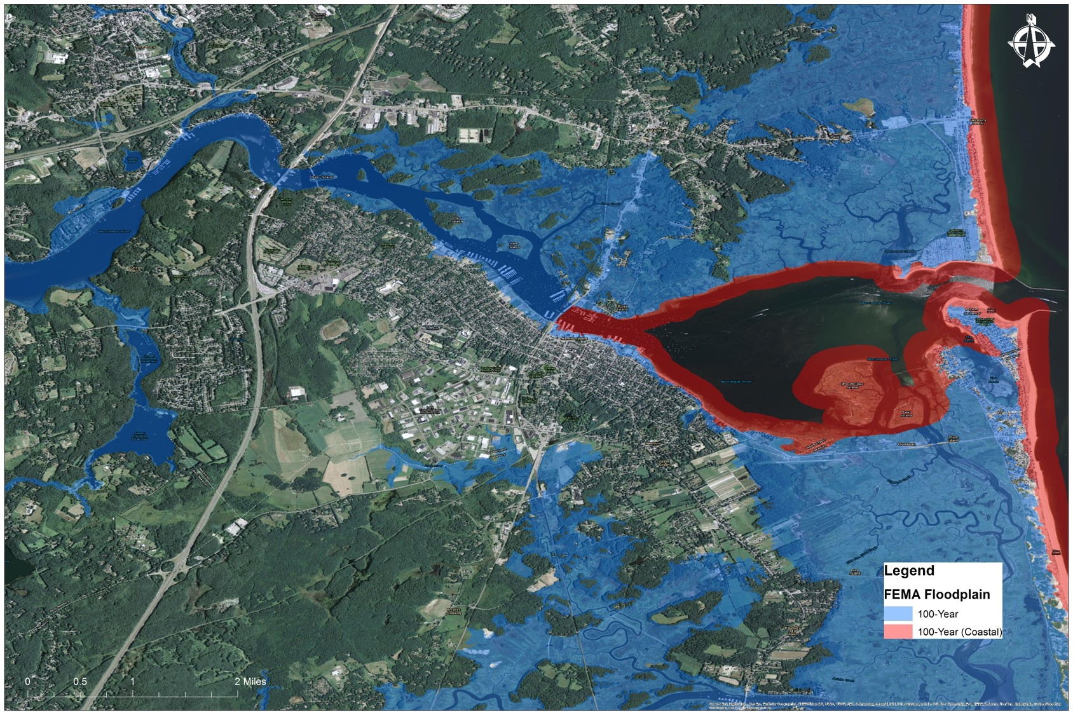
FLOOD HAZARD MAP FOR NEWBURYPORT (CREDIT: TETRA TECH)
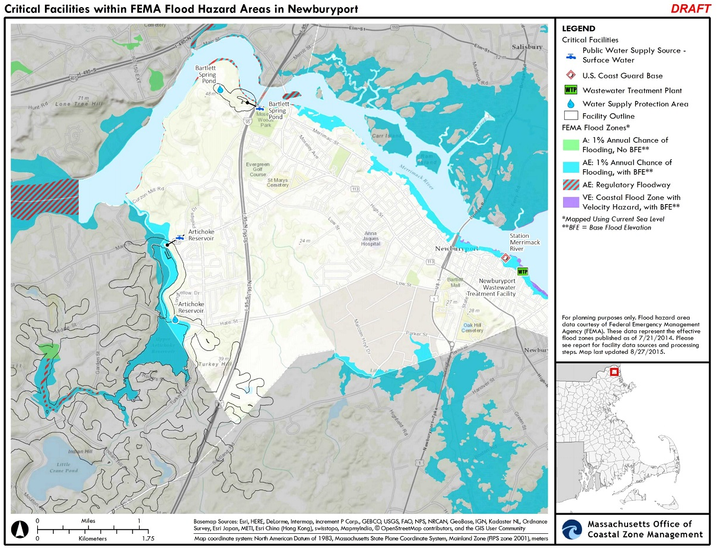
CRITICAL FACILITIES MAP FOR NEWBURYPORT (CREDIT: MASSACHUSETTS OFFICE OF COASTAL ZONE MANAGEMENT)

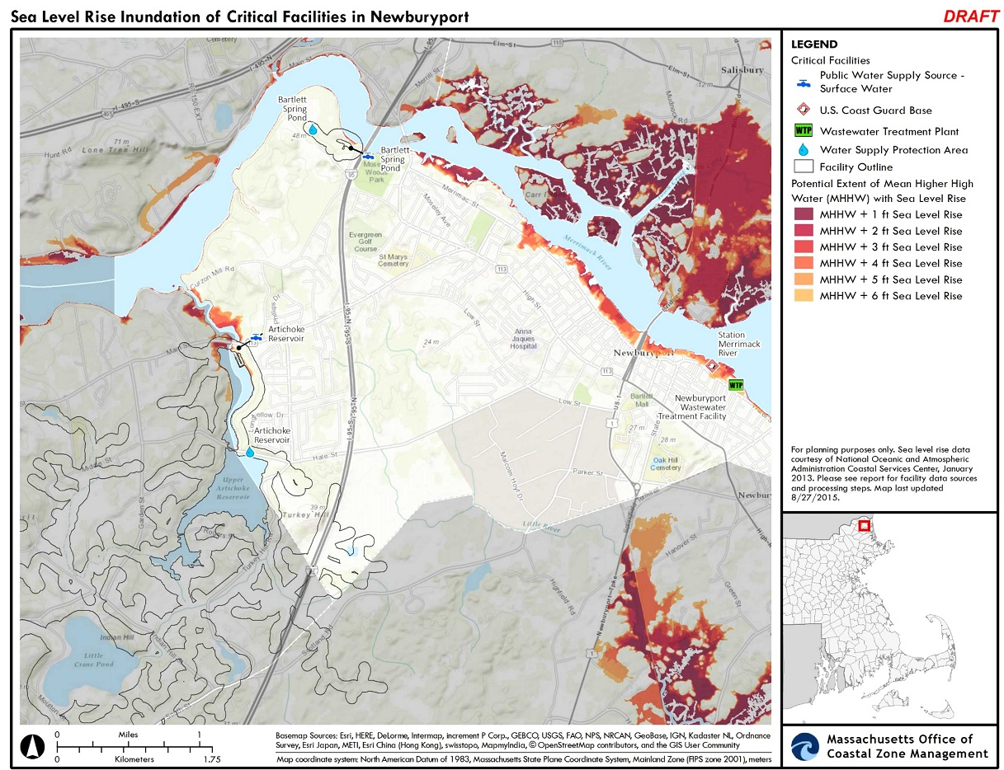
SEA LEVEL RISE MAP FOR NEWBURYPORT (CREDIT: MASSACHUSETTS OFFICE OF COASTAL ZONE MANAGEMENT)

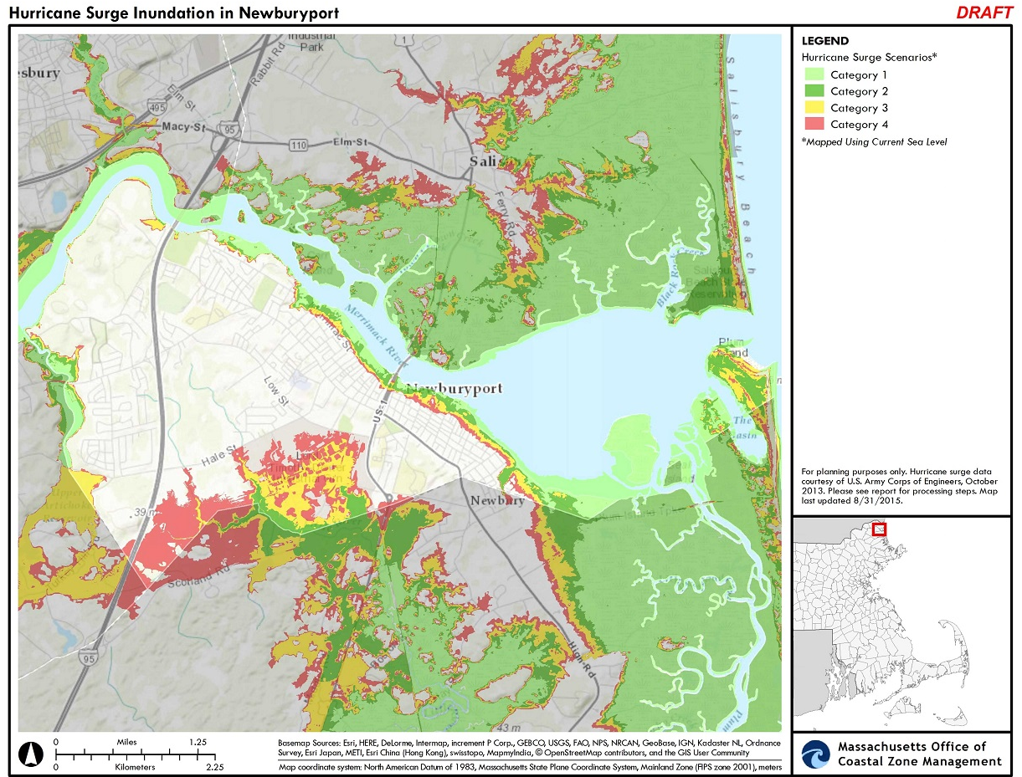
HURRICANE MAP FOR NEWBURYPORT (CREDIT: MASSACHUSETTS OFFICE OF COASTAL ZONE MANAGEMENT)

www.nwf.org/News-and-Magazines/Media-Center/News-by-Topic/Wildlife/2014/06-17-14-NWF-Awarded-2-9-Million-Grant-to-Restore-Massachusetts-Great-Marsh.aspxwww.nwf.org/News-and-Magazines/Media-Center/News-by-Topic/Wildlife/2014/06-17-14-NWF-Awarded-2-9-Million-Grant-to-Restore-Massachusetts-Great-Marsh.aspx
www.epa.gov/raine
www.floods.org/NoAdverseImpact/NAI_Toolkit_2003.pdf
(www.ready.gov/kids)

