PRESERVATION RESTRICTION AGREEMENT
between the
PEOPLE’S UNITED METHODIST CHURCH
and the
CITY OF NEWBURYPORT, Acting By And Through Its
NEWBURYPORTPORT HISTORICAL COMMISSION

THIS PRESERVATION RESTRICTION (this “Restriction”), is made this day of , 2020, between the People’s United Methodist Church (“Grantor”), having an address of 64 Purchase Street, Newburyport, Massachusetts, 01950, and the City of Newburyport acting by and through its Newburyport Historical Commission ("Grantee"), a governmental body in the Commonwealth of Massachusetts.

WITNESSETH:

WHEREAS, Grantor is owner in fee simple of certain real property located at 64 Purchase Street, in the City of Newburyport, Essex County, Massachusetts (hereinafter referred to as the "Property"), being that property conveyed by First Methodist Episcopal Society to Peoples Methodist Church in a deed dated July 8, 1965 and recorded on July 13, 1965 with the Essex County Registry of Deeds, Book 5284, Page 199, more particularly described in the Legal Description (Exhibit A), attached hereto and incorporated herein by this reference, and shown on an Assessor Parcel Map (Exhibit B), attached hereto and incorporated herein by this reference, said Property including the following building (hereinafter referred to as the “Building”);

This Building was built in 1825, raised and remodeled in 1845 with character-defining features of the Renaissance Revival style, remodeled again in 1869-1871 with character-defining features of the Italianate style, and the tower was added in 1888. The Building rests on a brick foundation. The elevations are clad in synthetic clapboard siding, and the broad corner pilasters are clad in synthetic siding as well. As indicated in the 1980 MHC Building Form (Exhibit C), the lower level was previously clad with rusticated boards and the upper level with wood clapboards. It is unknown if these earlier historic materials remain in whole or part beneath the current exterior synthetic clapboard siding. A raised beltcourse spans the front and side elevations between the first and second stories. The gable roof is clad in asphalt shingles and has a projecting molded box cornice with partial returns across the gable ends, and broad frieze boards below that are ornamented, on the front elevation only, with modillion blocks, the sides of which have incised carvings. It is unknown what the original roof cladding material was. The 1888 tower extends from the northeast corner of the Building. The tower is also clad in synthetic clapboard siding, and its broad corner pilasters are also clad in synthetic siding. The tower was also previously clad in the same wood materials as the main block. The upper portion of the tower elevations project forward slightly with an arch. The tower has a hip roof, also clad in asphalt shingles. The frieze boards of this roof entablature are ornamented with wood raised quatrefoil carvings. A tall hexagonal cupola sits atop this roof. Alternating elevations of the cupola originally had louvered openings, but are now infilled with flush boards. The other elevations are finished with vertical board siding. Above the cupola is a tall, narrow, six-sided spire clad in wood shingles, which may have been the original cladding material for all roofs. The spire is capped by a gilt-clad Angel Gabriel weather vane made of copper. The weathervane is a 2018 replica of the original 1840 weather vane that originally was on a Newburyport Unitarian Universalist church that was destroyed by fire. It was placed on this church in ca. 1895. The original was removed in the 1980s and is now in the Smithsonian Institute. The first replacement weather vane deteriorated and was replaced by the current one.

The front elevation of the Building is symmetrical in design. There is a centered entrance which consists of paired replacement panel doors set in a surround with a narrow segmentally-arched hooded lintel. The front entrance is accessed by a one-step threshold, for which a low handicap ramp has been built along the right side of the elevation. Almost all windows have been replaced with synthetic windows that have applied muntins. Fenestration on the first story of this elevation consists of paired 4/4 double-hung sash on either side of the entrance. These windows have surrounds with heavy molded lintels. The prior windows, as seen in the 1980 MHC Building Form, had wood 6/6 double-hung sash. There are three tall window systems on the upper level of this elevation, the centered one being taller than the outlying two. Each has a 6/6 double-hung window, above which is a 6/6 fixed sash followed by a multi-paned fixed round-headed window. It is unclear to what degree these windows adhere to an original or historically significant muntin pattern. These windows also have surrounds with heavy molded lintels.

The front elevation of the tower has a second entrance similar in design to the centered front entrance, also with replacement panel doors, and also accessed by a short concrete access ramp. Fenestration on the tower includes a 6/6 double-hung sash on the first story of the southeast elevation, and window systems, similar to the two outlying window systems on the front elevation of the main block, on the second story of the northeast and southeast elevations.

Fenestration on the side elevations of the main block consist of 6/6 double-hung sash on the first story and taller window systems on the upper level with 6/6 double-hung sash below a fixed 9-lite sash. It is unclear to what degree these windows adhere to an original or historically significant muntin pattern. The surrounds on the first story are entirely covered or clad in synthetic trim. The upper level windows have the original wood surrounds exposed, which include a segmentally-arched hooded lintel. There is a modern door at the rear of the southwest elevation, and a fire escape leads up to the last window on that elevation which has been partially replaced by a door. There is a centered rear ell which rises up the main roof ridge. There are no openings on the rear elevation;

WHEREAS, the Building is historically significant for its architecture and associations, retaining integrity of craftsmanship, setting, materials and design; is a contributing resource within the Newburyport National Register District listed on August 2, 1984; is listed in the State Register of Historic Places; and qualifies for the protections of perpetual preservation restrictions under M.G.L. Chapter 184, sections 31-33;

WHEREAS, Grantor and Grantee both recognize the architectural, historic and cultural values (hereinafter “Preservation Values”) of the Building and Property, and have the common purpose of preserving the aforesaid preservation values and significance of the Building and Property;

WHEREAS, the Building’s and Property’s Preservation Values are documented with the following;

Massachusetts Historical Commission Inventory Building Form prepared in November, 1980 by Mary Jane Stirgwolt (Exhibit C), attached hereto and incorporated herein by this reference,

Six (6) photographs taken by Novak Niketic in July, 2020 (Exhibit D), attached hereto and incorporated herein by this reference. Archival prints of these photographs will be stored by the Grantee at Newburyport City Hall, Historical Commission files.

Exhibit A - Legal Description, Exhibit B - Assessor map, Exhibit C - MHC Inventory Building Form, and Exhibit D - Photographs are hereinafter referred to as the “Baseline Documentation”, which Baseline Documentation the parties agree provides an accurate representation of the Building as of the effective date of this grant;

WHEREAS, the City of Newburyport City Council appropriated Community Preservation Act funds in a meeting convened on July 10, 2017, for the repair and restoration of the Building’s steeple;

WHEREAS, the grant of a preservation restriction by Grantor to Grantee on the Property will assist in preserving and maintaining the Building and its architectural, historic, and cultural features for the benefit of the people of the City of Newburyport, Essex County, the Commonwealth of Massachusetts, and the United States of America;

WHEREAS, to that end, Grantor desires to grant to Grantee, and Grantee desires to accept a preservation restriction (the "Restriction") in gross in perpetuity over the Property and the exterior of the Building pursuant to the Act.

NOW, THEREFORE, in consideration of Ten Dollars ($10.00) and other good and valuable consideration, receipt and sufficiency of which is hereby acknowledged, Grantor does hereby irrevocably grant and convey unto the Grantee this Restriction in gross in perpetuity over the Property.

1. Purpose. It is the purpose of this Restriction to assure that the architectural, historic, and cultural features of the exterior of the Building, as described and documented in the Baseline Documentation and Exhibit E (Restriction Guidelines), will be retained and maintained forever substantially in their historically-appropriate condition for preservation purposes and to prevent any use or change to the exterior of the Building or the Property that will significantly impair or interfere with the Building’s Preservation Values (the “Purpose of this Restriction”). Characteristics that contribute to the architectural and historical integrity of the Property including include, but are not limited to, the setting and location of the Building; and architectural features, materials, appearance, and workmanship of the Building. All Exhibits shall be attached to and recorded with this Restriction.

2.1 Grantor's Covenants: Covenant to Maintain. Grantor agrees at all times and to the best of its ability to maintain the Building and the Property in sound structural condition and good state of repair in accordance with the terms of this paragraph (allowing for historically-accurate restoration that may be made from time to time). It is the Grantor’s intent that the exterior of the Building be maintained in a physical appearance and composition that is as close to its current appearance and composition as is reasonably possible, excepting the alterations and additions allowable per the Restriction Guidelines (Exhibit E). Grantor’s obligation to maintain shall require replacement, repair, and reconstruction by Grantor whenever necessary to preserve the exterior of the Building in sound structural condition and a good state of repair. Subject to the casualty provisions of Paragraphs 7 and 8, this obligation to maintain shall require repair, restoration, replacement, rebuilding, and reconstruction of the Building whenever necessary in accordance with The Secretary of the Interior's Standards for the Treatment of Historic Properties with Guidelines for Preserving. Rehabilitating, Restoring, and Reconstructing Historic Buildings (36 C.F.R. 67 and 68), as these may be amended from time to time (the "Secretary's Standards"), and in accordance with the Restriction Guidelines in Exhibit E.

2.2 Grantor's Covenants: Prohibited Activities. The following acts or uses are expressly forbidden on, over, or under the Property, except as otherwise conditioned in this paragraph:

- the Building (or any portion thereof) shall not be demolished, removed, moved or razed except as provided in Paragraphs 7 and 8;
- the dumping of ashes, trash, or rubbish is prohibited on the Property; and
- no above-ground utility transmission lines, except those reasonably necessary for the existing Building, may be created on the Property, subject to any utility easements already recorded;

3.1 Conditional Rights Requiring Approval by Grantee. Without the prior express written approval of the Grantee, which approval may not be unreasonably withheld but which may be subject to such reasonable conditions as Grantee in its discretion may determine, Grantor shall not make any changes to the exterior of the Building, including the alteration, partial removal, construction, remodeling, or other physical or structural change, including signs or advertisements (excepting a plaque giving notice of the historic significance of the Building or Property in accordance with Paragraph 6), any change in material or color or any change to the footprint, size, mass, ridgeline, and rooflines of the Building, and removal, replacement or alteration of any character-defining features, such as doors and surrounds and cornice trim. Activities by Grantor to maintain the exterior of the Building which are intended to be performed in accordance with the provisions of Paragraph 2.1, and which are of a minor nature, shall not require the prior approval of the Grantee. For the purposes of this section, interpretation of what constitutes ordinary maintenance of a minor nature is governed by the Restriction Guidelines (Exhibit E).

3.2 Review of Grantor's Requests for Approval. Where Grantee’s permission is required under Paragraph 3.1, Grantor shall submit to the Grantee two copies of information (including plans, specifications, and designs where appropriate) identifying the proposed activity with reasonable specificity. In connection therewith, Grantor shall also submit to the Grantee a timetable for the proposed activity sufficient to permit the Grantee to monitor such activity. Within forty-five (45) days of the Grantee's receipt of any plan or written request for approval hereunder, the Grantee shall certify in writing that (a) it approves the plan or request, or (b) it disapproves the plan or request as submitted, in which case the Grantee shall provide Grantor with written suggestions for modification or a written explanation for the Grantee's disapproval. Any failure by the Grantee to act within forty-five (45) days of receipt of Grantor's submission or resubmission of plans or requests shall be deemed to constitute approval by the Grantee of the plan or request as submitted and to permit Grantor to undertake the proposed activity in accordance with the plan or request submitted so long as the request sets forth the provision of this section relating to deemed approval following the passage of time, provided that nothing herein shall be construed to permit Grantor to undertake any of the activities prohibited hereunder.

3.3 Archaeological Activities. The conduct of archaeological activities, including without limitation survey, excavation, and artifact retrieval, may occur only following the submission of an archaeological field investigation plan prepared by Grantor and approved in writing by the Grantee and the State Archaeologist of the Massachusetts Historical Commission pursuant to M.G.L. c. 9, § 27C and 950 C.M.R. 70.00.

4. Standards for Review. In exercising any authority created by the Restriction to inspect the Building; to review any construction, repair, restoration, alteration, reconstruction or construction; or to review casualty damage or to reconstruct or approve reconstruction of the Building following casualty damage, the Grantee shall apply the Secretary's Standards and the Restriction Guidelines in Exhibit E.

5. Public Access. This Restriction does not require public access.

6. Grantor's Reserved Rights. Subject to the provisions of Paragraphs 2.1, 2.2, and 3.1, the following rights, uses, and activities of or by Grantor on, over, or under the Property are permitted by this Restriction and by the Grantee without further approval by the Grantee:

- the right to engage in all those acts and uses that: (i) are permitted by governmental statute or regulation; (ii) do not substantially impair the Preservation Values of the Building and Property; and (iii) are not inconsistent with the Purpose of this Restriction;
- pursuant to the provisions of Paragraph 2.1, the right to maintain and repair the exterior of the Building strictly according to the Secretary's Standards. As used in this subparagraph, the right to maintain and repair shall mean the use by Grantor of in-kind materials and colors, applied with workmanship comparable to that which was used in the construction or application of those materials being repaired or maintained, for the purpose of retaining in good condition the appearance and construction of the exterior of the Building and Property. The right to maintain and repair as used in this subparagraph shall not include the right to make changes in appearance, materials, colors, and workmanship from that existing prior to the maintenance and repair without the prior approval of the Grantee in accordance with the provisions of Paragraphs 3.1 and 3.2;
- subject to prior review and approval by Grantee, under the terms and conditions of paragraphs 3.1 and 3.2 herein, which approval shall not be unreasonably withheld, the right to new construction on the Property not attached to the Building, and not blocking the view of the Building from public ways, subject to all applicable licenses, permits, and approvals, provided in addition that any new construction shall meet the Secretary’s Standards; and
- the right to provide and maintain a plaque on the Property giving notice of the historical significance of the Building, subject to Grantee’s reasonable approval.

7. Casualty Damage or Destruction. In the event that the Building shall be materially damaged or destroyed by fire, flood, windstorm, hurricane, earth movement, or other casualty, Grantor shall notify the Grantee in writing within fourteen (14) days of the damage or destruction, such notification including what, if any, emergency work has already been completed. No repairs to or reconstruction of the exterior of any type, other than emergency work to prevent further damage to the structural integrity of the Building or the exterior of the Building, shall be undertaken by Grantor without the Grantee's prior written approval of the work. Within seventy-five (75) days of the date of damage or destruction, if required by the Grantee, Grantor at its expense shall submit to the Grantee a written report prepared by a qualified restoration architect and an engineer who are acceptable to the Grantor and the Grantee, which report shall include the following:

- an assessment of the nature and extent of the damage;
- a determination of the feasibility of the restoration of the Building and/or reconstruction of damaged or destroyed portions of the Building; and
- a report of such restoration/reconstruction work necessary to return the Building to the condition existing at the date hereof.

8. Review After Casualty Damage or Destruction. If, after reviewing the report provided in Paragraph 7 and assessing the availability of insurance proceeds after satisfaction of any mortgagee's/lender's claims under Paragraph 9, Grantor and the Grantee agree that the Purpose of the Restriction will be served by such restoration/reconstruction, Grantor and the Grantee shall establish a schedule under which Grantor shall complete the restoration/reconstruction of the Building in accordance with plans and specifications consented to by the parties up to at least the total of the casualty insurance proceeds available to Grantor.

If, after reviewing the report and assessing the availability of insurance proceeds after satisfaction of any mortgagee's/lender's claims under Paragraph 9, Grantor and the Grantee agree that restoration/reconstruction of the Building is impractical or impossible, or agree that the Purpose of the Restriction would not be served by such restoration/reconstruction, Grantor may, with the prior written consent of the Grantee, alter, demolish, remove or raze the Building, and/or construct new improvements on the Property. In the event that the Building is razed or removed with the approval of the Grantee, Grantor and Grantee may agree to seek to extinguish this Restriction in accordance with the laws of the Commonwealth of Massachusetts and Paragraph 21 hereof.

If, after reviewing the report and assessing the availability of insurance proceeds after satisfaction of any mortgagee's/lender's claims under Paragraph 9, Grantor and the Grantee are unable to agree that the Purpose of the Restriction will or will not be served by such restoration/reconstruction, the matter may be referred by either party to binding arbitration and settled in accordance with the Commonwealth of Massachusetts arbitration statute then in effect, and all other applicable laws, rules, regulations, and ordinances.

9. Insurance. Grantor shall keep the Building insured by an insurance company rated "A-" or better by Best's, or is current-day equivalent, as the case may be, for the full replacement value against loss from the perils commonly insured under standard fire and extended coverage policies and comprehensive general liability insurance against claims for personal injury, death, and property damage. Property damage insurance shall include change in condition and building ordinance coverage, in form and amount sufficient to replace fully the damaged Building without cost or expense to Grantor or contribution or coinsurance from Grantor. Grantor shall deliver annually and within ten (10) business days of any additional written request by the Grantee, certificates of such insurance coverage. Upon presentation of evidence by the Grantee that the insured value is less than the actual replacement value, then the Grantor shall purchase additional insurance sufficient to cover the actual replacement value. In the event that such a presentation has been made that the insurance is insufficient, the Grantor shall pay for the Grantee’s cost in procuring such evidence. Provided, however, that whenever the Property is encumbered with a mortgage or deed of trust nothing contained in this paragraph shall jeopardize the prior claim, if any, of the mortgagee/lender to the insurance proceeds.

10. Hold Harmless. Grantor hereby agrees to protect, hold harmless, and defend Grantee, its boards, commissions, appointees, agents, directors, employees, or independent contractors from and against any and all claims, liabilities, expenses, costs, damages, losses, and expenditures (including reasonable attorneys' fees and disbursements hereafter incurred) arising out of or in connection with injury to or death of any person as a result of the existence of this Restriction; physical damage to the Building and the Property; the presence or release in, on, or about the Building and the Property, at any time, of any substance now or hereafter defined, listed, or otherwise classified pursuant to any law, ordinance, or regulation as a hazardous, toxic, polluting or contaminating substance; or other injury or other damage occurring on or about the Building and the Property; unless such injury, death, or damage is caused by Grantee or its boards, commissions, appointees, agents, directors, employees, or independent contractors.

11. Written Notice. Any notice which either Grantor or Grantee may desire or be required to give to the other party shall be in writing and shall be mailed postage prepaid by overnight courier, facsimile transmission, registered or certified mail with return receipt requested, or hand delivered as follows:

To Grantor: People’s United Methodist Church
64 Purchase Street
Newburyport, MA 01950

To Grantee: City of Newburyport by and through
Newburyport Historical Commission
Newburyport City Hall
60 Pleasant Street
Newburyport, MA 01950

or to such address as any of the above parties shall designate from time to time by written notice to the other. In the event no current address is known or can be reasonably obtained for the party to which notice is intended to be given, then the party giving notice shall publish such notice in a newspaper of general circulation covering on at least a weekly basis the City of Newburyport, or its modern-day functional equivalent.

12. Evidence of Compliance. Upon request by Grantor, Grantee shall promptly furnish Grantor with certification that, to the best of Grantee's knowledge, Grantor is in compliance with the obligations of Grantor contained herein, or that otherwise evidences the status of this Restriction to the extent of Grantee's knowledge thereof.

13. Inspection. Upon reasonable prior notice to Grantor, there is hereby granted to Grantee and its representatives the right to enter the Property at reasonable times and in a reasonable manner for the purpose of inspecting the same to determine compliance with this Preservation Restriction Agreement. Grantee shall inspect the property a minimum of one time per year.

14. Grantee's Remedies The rights hereby granted shall include the right to enforce this Agreement by appropriate legal proceedings and to obtain injunctive and other equitable relief against any violations, including, without limitation, relief requiring restoration of the Property to its condition prior to the time of the injury complained of (it being agreed that Grantee shall have no remedy at law), and shall be in addition to and not in limitation of any other rights and remedies available to Grantee; provided, however, prior to commencement of any legal proceedings the Grantee shall first send a written notice of its intention to pursue legal action with a statement of the factual and legal basis of such claim and within thirty (30) days of receipt of such notice by the Grantor both parties shall enter in good faith into mediation with a mutually agreeable neutral third-party trained in resolving disputes. The expense of mediation shall be split evenly between the parties.

Provided that a violation of this Agreement is acknowledged by Grantor or determined by a court of competent jurisdiction to have occurred, Grantor covenants and agrees to reimburse Grantee all reasonable costs and expenses (including without limitation reasonable counsel fees) incurred in enforcing this Agreement or in taking reasonable measure to remedy, abate any violation thereof. By its acceptance, Grantee does not undertake any liability or obligation relating to the condition of the Property, including with respect to compliance with hazardous materials or other environmental laws and regulations. This Agreement shall be enforced by Grantee in its sole discretion. Nothing herein shall impose upon the Grantee any affirmative obligation or liability relating to the condition of the Property. Failure by the Grantee to enforce any provision or condition set forth herein, or to exercise any rights hereby conveyed, shall not constitute a release or waiver of any such right or condition.

15. Notice from Government Authorities. Grantor shall deliver to Grantee copies of any notice of violation or lien relating to the Building and the Property received by Grantor from any government authority within five (5) days of receipt by Grantor. Upon request by Grantee, Grantor shall promptly furnish Grantee with evidence of Grantor's compliance with such notice or lien where compliance is required by law.

16. Notice of Proposed Sale. Grantor shall promptly notify Grantee in writing of any proposed sale of the Property and provide the opportunity for Grantee to explain the terms of the Restriction to potential new owners prior to sale closing.

17. Runs with the Land. Except as provided in Paragraphs 8 and 21, the obligations imposed by this Restriction shall be effective in perpetuity and shall be deemed to run as a binding servitude with the Property. This Restriction shall extend to and be binding upon Grantor and Grantee, their respective successors in interest and all persons hereafter claiming under or through Grantor and Grantee, and the words "Grantor" and "Grantee" when used herein shall include all such persons. Any right, title, or interest herein granted to Grantee also shall be deemed granted to each successor and assign of Grantee and each such following successor and assign thereof, and the word "Grantee" shall include all such successors and assigns.

Anything contained herein to the contrary notwithstanding, an owner of the Property shall have no obligation pursuant to this instrument where such owner shall cease to have any ownership interest in the Property by reason of a bona fide transfer. The restrictions, stipulations and covenants contained in this Restriction shall be inserted by Grantor, verbatim or by express reference, in any subsequent deed or other legal instrument by which Grantor divests itself of either the fee simple title to or any lesser estate in the Property or any part thereof, including by way of example and not limitation, a lease of all or a portion of the Property.

18. Assignment. In the event that Grantee shall cease to function in its present capacity, Grantee may convey, assign, or transfer this Restriction to a unit of federal, state, or local government or to a similar local, state, or national organization that is a charitable corporation or trust qualified under the Act to hold a preservation restriction, provided that any such conveyance, assignment or transfer requires that the Purpose for which the Restriction was granted will continue to be carried out. Grantor shall give prior written approval of such conveyance, assignment, or transfer by Grantee, such approval not to be unreasonably withheld.

19. Alternate Designee. Grantee may, at its discretion, remove and replace its designee to administer, manage, and enforce this Restriction, provided that any new designee is qualified as such under the Act and other applicable law.

20. Recording and Effective Date. Grantor shall do and perform at its own cost all acts necessary to the prompt recording of this instrument in the Essex County Registry of Deeds. Grantor and Grantee intend that the restrictions arising under this Restriction take effect on the day and year this instrument is recorded in the Essex County Registry of Deeds.

21. Extinguishment. Grantor and Grantee hereby recognize that an unexpected change in the conditions surrounding the Property may make impossible the continued ownership or use of the Property for the Purpose of this Restriction and necessitate extinguishment of the Restriction. Such a change in conditions may include, but is not limited to, partial or total destruction of the Building resulting from casualty. Such an extinguishment must meet all the requirements of the Act and the Laws of the Commonwealth for extinguishment, including approvals by the City of Newburyport and the Massachusetts Historical Commission following public hearings to determine that such extinguishment is in the public interest.

In the event of a sale of the Property, any proceeds of sale attributable to improvements in the Building funded by the Grantor’s Community Preservation Fund shall be deposited into the Grantor’s Community Preservation Fund in accordance with M.G.L. c. 44B (“Chapter 44B”). Should the Grantee’s Community Preservation Fund no longer exist for any reason, such as the Grantor having opted out of Chapter 44B, the proceeds shall be used in a manner consistent with the preservation purpose set forth herein as a continuing trust.

22. Condemnation. If all or any part of the Property is taken under the power of eminent domain by public, corporate, or other authority, or otherwise acquired by such authority through a purchase in lieu of a taking, Grantor and Grantee shall join in appropriate proceedings at the time of such taking to recover the full value of those interests in the Property that are subject to the taking and all incidental and direct damages resulting from the taking. All expenses reasonably incurred by Grantor and Grantee in connection with such taking shall be paid out of the recovered proceeds. Such recovered proceeds shall be paid in the manner as set forth in Paragraph 21.

23. Insertion in Subsequent Instruments
Grantor shall insert a reference to this Agreement, such reference to include Registry book and page number of this Agreement, into any subsequent deed or other legal instrument by which Grantor divests itself of either the fee simple title or any lesser estate in the Property. Concurrently, with its entering into any such deed or other legal instrument, Grantor shall give written notice to Grantee of same. Failure by Grantor to comply with the requirements of this paragraph 23 shall not affect the validity, enforceability or priority of this Agreement or any lien arising hereunder.

24. Interpretation. The following provisions shall govern the effectiveness, interpretation, and duration of the Restriction:

- Any rule of strict construction designed to limit the breadth of restrictions on alienation or use of the Property shall not apply in the construction or interpretation of this Restriction and this instrument shall be interpreted broadly to affect its Purpose and the transfer of rights and the restrictions on use herein contained.
- This instrument may be executed in two counterparts, one of which is to be retained by Grantor and the other, after recording, to be retained by Grantee. In the event of any disparity between the counterparts produced, the recorded counterpart shall in all cases govern. Except as provided in the preceding sentence, each counterpart shall constitute the entire agreement of the parties.
- This instrument is made pursuant to the Act, but the invalidity of such Act or any part thereof shall not affect the validity and enforceability of this Restriction according to its terms, it being the intent of the parties to agree and to bind themselves, their successors and their assigns in perpetuity to each term of this instrument whether this instrument be enforceable by reason of any statute, common law or private agreement either in existence now or at any time subsequent hereto.
- Nothing contained herein shall be interpreted to authorize or permit Grantor to violate any ordinance or regulation relating to building materials, construction methods, or use. In the event of any conflict between any such ordinance or regulation and the terms hereof Grantor promptly shall notify Grantee of such conflict and shall cooperate with Grantee and the applicable governmental entity to accommodate the purposes of both this Restriction and such ordinance or regulation.
- The invalidity or unenforceability of any provision of this Restriction shall not affect the validity or enforceability of any other provision of this Restriction.

25. Amendment. If circumstances arise under which an amendment to or modification of this Restriction would be appropriate, Grantor and Grantee may by mutual written agreement jointly amend this Restriction, provided that no amendment shall be made that will adversely affect the qualification of this Restriction or the status of Grantee under any applicable law. Any such amendment shall be consistent with the protection of the Preservation Values of the Property and the Purpose of this Restriction; shall not affect its perpetual duration; shall not permit any private inurement to any person or entity; and shall not adversely impact the overall architectural and historic values protected by this Restriction. Any such amendment shall be effective when the requirements of the Act with respect to amendments have been met and the amendment is recorded in the Essex County Registry of Deeds. Nothing in this paragraph shall require Grantor or Grantee to agree to any amendment or to consult or negotiate regarding any amendment.

TO HAVE AND TO HOLD, the said Preservation Restriction, unto the said Grantee and its successors and permitted assigns forever.
IN WITNESS WHEREOF, Grantor and Grantee have set their hands under seal on the days and year set forth below.

GRANTOR: People’s United Methodist Church
By and through its Chairman of the Board of Trustees

Duncan A. MacBurnie

and
People’s United Methodist Church
By and through its Treasurer

Vicki L. Decie

COMMONWEALTH OF MASSACHUSETTS

Essex, ss.

On this ___ day of ____, 2020, before me, the undersigned notary public, personally appeared ___________, provided to me through satisfactory evidence of identification which was _______________________ to be the person whose name is signed on the proceeding or attached document, and acknowledged to me that _____________ signed it voluntarily for its stated purpose, as Chairman of the Board of Trustees, of People’s United Methodist Church.

______________________________
Notary Public
My commission expires:

(seal)

Essex, ss.

On this ___ day of ____ , 2020, before me, the undersigned notary public, personally appeared ______________, provided to me through satisfactory evidence of identification which was _______________________ to be the person whose name is signed on the proceeding or attached document, and acknowledged to me that ________________ signed it voluntarily for its stated purpose, as Treasurer, of People’s United Methodist Church.

______________________________
Notary Public
My commission expires:

(seal)
ACCEPTANCE AND APPROVAL BY CITY OF NEWBURYPORT

I, the undersigned City Clerk of the City of Newburyport, Massachusetts, hereby certify that at a meeting duly held on _________________, 20__, the City Council voted to accept and approve the foregoing Preservation Restriction for the preservation of the historic resource of said City and being in the public interest pursuant to M.G.L. Chapter 184, sections 31-33.

CITY OF NEWBURYPORT

By its Clerk,

____________________________
Richard B. Jones

The undersigned hereby certifies that the foregoing Preservation Restriction has been accepted and approved by the City of Newburyport.

CITY OF NEWWBURYPORT

By its Mayor,

____________________________
Donna D. Holaday

COMMONWEALTH OF MASSACHUSETTS

Essex, ss.

On this ___ day of ______, 2020, before me, the undersigned notary public, personally appeared ______________, provided to me through satisfactory evidence of identification which was _______________________ to be the person whose name is signed on the proceeding or attached document, and acknowledged to me that ___________ signed it voluntarily for its stated purpose, as Clerk, City of Newburyport.

______________________________
Notary Public
My commission expires:

(seal)

Essex, ss.

On this ___ day of ______, 2020, before me, the undersigned notary public, personally appeared Donna D. Holaday , provided to me through satisfactory evidence of identification which was _______________________ to be the person whose name is signed on the proceeding or attached document, and acknowledged to me that Donna D. Holaday signed it voluntarily for its stated purpose, as Mayor, City of Newburyport.

______________________________
Notary Public
My commission expires:

(seal)

ACCEPTANCE AND APPROVAL BY NEWBURYPORT HISTORICAL COMMISSION

On _____________, 2020, the Newburyport Historical Commission, by majority vote, voted to Accept this Agreement.

Historical Commission:

Glenn Richards, Chair

Patricia Peknik, Vice-chair

Malcolm Carnwath

Christopher Fay

Peter McNamee

Joe Morgan

Ron Ziemba

COMMONWEALTH OF MASSACHUSETTS
Essex, ss.

On this ___ day of ______, 2020, before me, the undersigned notary public, personally appeared Glenn Richards, provided to me through satisfactory evidence of identification which was _______________________ to be the person whose name is signed on the proceeding or attached document, and acknowledged to me that Glenn Richards signed it voluntarily for its stated purpose, as Chair, City of Newburyport Historical Commission.

______________________________
Notary Public
My commission expires:

(seal)

Essex, ss.

On this ___ day of ______, 2020, before me, the undersigned notary public, personally appeared Patricia Peknik, provided to me through satisfactory evidence of identification which was _______________________ to be the person whose name is signed on the proceeding or attached document, and acknowledged to me that Patricia Peknik signed it voluntarily for its stated purpose, as Vice-Chair, City of Newburyport Historical Commission.

______________________________
Notary Public
My commission expires:

(seal)

Essex, ss.

On this ___ day of ______, 2020, before me, the undersigned notary public, personally appeared Malcolm Carnwath, provided to me through satisfactory evidence of identification which was _______________________ to be the person whose name is signed on the proceeding or attached document, and acknowledged to me that Malcolm Carnwath signed it voluntarily for its stated purpose, as Member, City of Newburyport Historical Commission.

______________________________
Notary Public
My commission expires:

(seal)

Essex, ss.

On this ___ day of ______, 2020, before me, the undersigned notary public, personally appeared Christopher Fay, provided to me through satisfactory evidence of identification which was _______________________ to be the person whose name is signed on the proceeding or attached document, and acknowledged to me that Christopher Fay signed it voluntarily for its stated purpose, as Member, City of Newburyport Historical Commission.

______________________________
Notary Public
My commission expires:

(seal)

Essex, ss.

On this ___ day of ______, 2020, before me, the undersigned notary public, personally appeared Peter McNamee, provided to me through satisfactory evidence of identification which was _______________________ to be the person whose name is signed on the proceeding or attached document, and acknowledged to me that Peter McNamee signed it voluntarily for its stated purpose, a Member, City of Newburyport Historical Commission.

______________________________
Notary Public
My commission expires:

(seal)

Essex, ss.

On this ___ day of ______, 2020, before me, the undersigned notary public, personally appeared Joe Morgan, provided to me through satisfactory evidence of identification which was _______________________ to be the person whose name is signed on the proceeding or attached document, and acknowledged to me that Joe Morgan signed it voluntarily for its stated purpose, a Member, City of Newburyport Historical Commission.

______________________________
Notary Public
My commission expires:

(seal)

Essex, ss.

On this ___ day of ______, 2020, before me, the undersigned notary public, personally appeared Ron Ziemba, provided to me through satisfactory evidence of identification which was _______________________ to be the person whose name is signed on the proceeding or attached document, and acknowledged to me that Ron Ziemba signed it voluntarily for its stated purpose, a Member, City of Newburyport Historical Commission.

______________________________
Notary Public
My commission expires:

(seal)

APPROVAL BY THE MASSACHUSETTS HISTORICAL COMMISSION

COMMONWEALTH OF MASSACHUSETTS

The undersigned Executive Director and Clerk of the Massachusetts Historical Commission, hereby certifies that the foregoing Preservation Restriction to the City of Newburyport, acting by and through its Newburyport Historical Commission (Grantee), has been approved by the Massachusetts Historical Commission in the public interest pursuant to MGL, Chapter 184, Section 32.

By: ___________________________________
Brona Simon, Executive Director and Clerk

COMMONWEALTH OF MASSACHUSETTS

Suffolk, ss.

On this ___ day of ____ , 2020, before me, the undersigned notary public, personally appeared Brona Simon proved to me through satisfactory evidence of identification which was personal knowledge to be the person whose name is signed on the proceeding or attached document, and acknowledged to me that Brona Simon signed it voluntarily for its stated purpose, as Executive Director and Clerk of the Massachusetts Historical Commission.

______________________________
Notary Public
My commission expires:
(seal)

EXHIBIT A

LEGAL DESCRIPTION

Parcel #1 with improvements thereon, in Newburyport, Massachusetts described in a 1965 deed, Book 5284, Page 199, bounded as follows:

Commencing at the Southerly corner thereof on Purchase Street by land formerly of Thurlow, now or formerly of Phinney; thence running Northeasterly by said land of Phinney and land now or formerly of DeRochemont 98.34 feet to land now or formerly of Leavitt; thence running Northwesterly by said land now or formerly of Leavitt 64.68 feet to land of Osgood; thence running Southwesterly by said land of Osgood 98.34 feet to said Purchase Street; thence running Southeasterly by said Purchase Street 66.99 feet to the bound begun at.

EXHIBIT B
Assessor Map

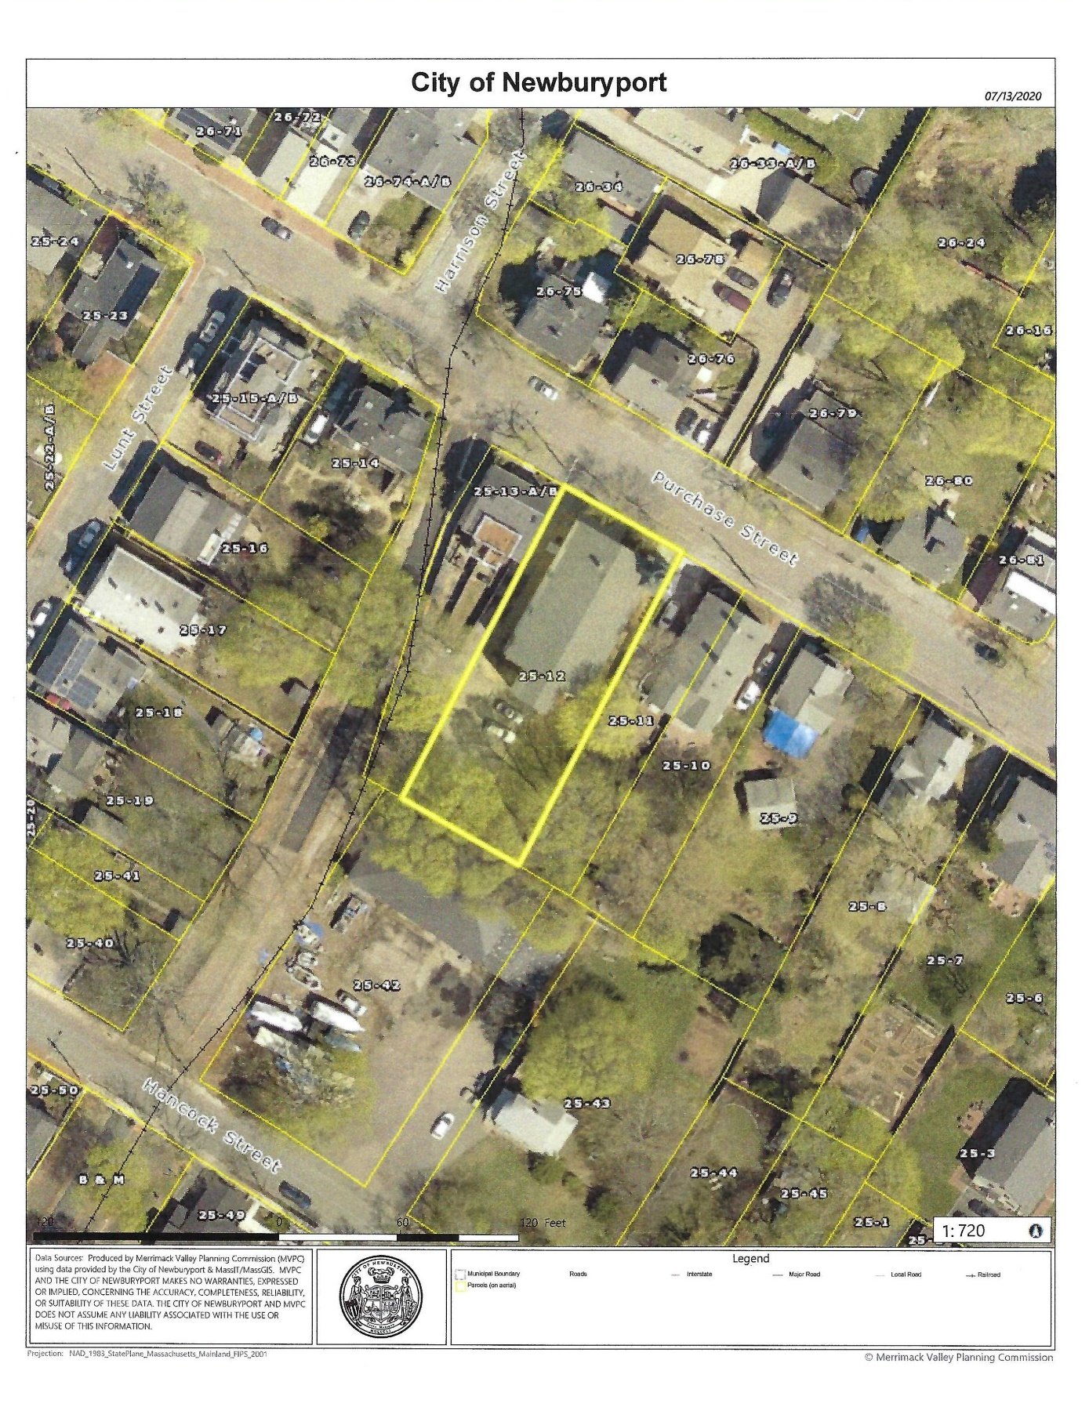

EXHIBIT C
MHC INVENTORY BUILDING FORM, prepared by Mary Jane Stirgwolt, November, 1980

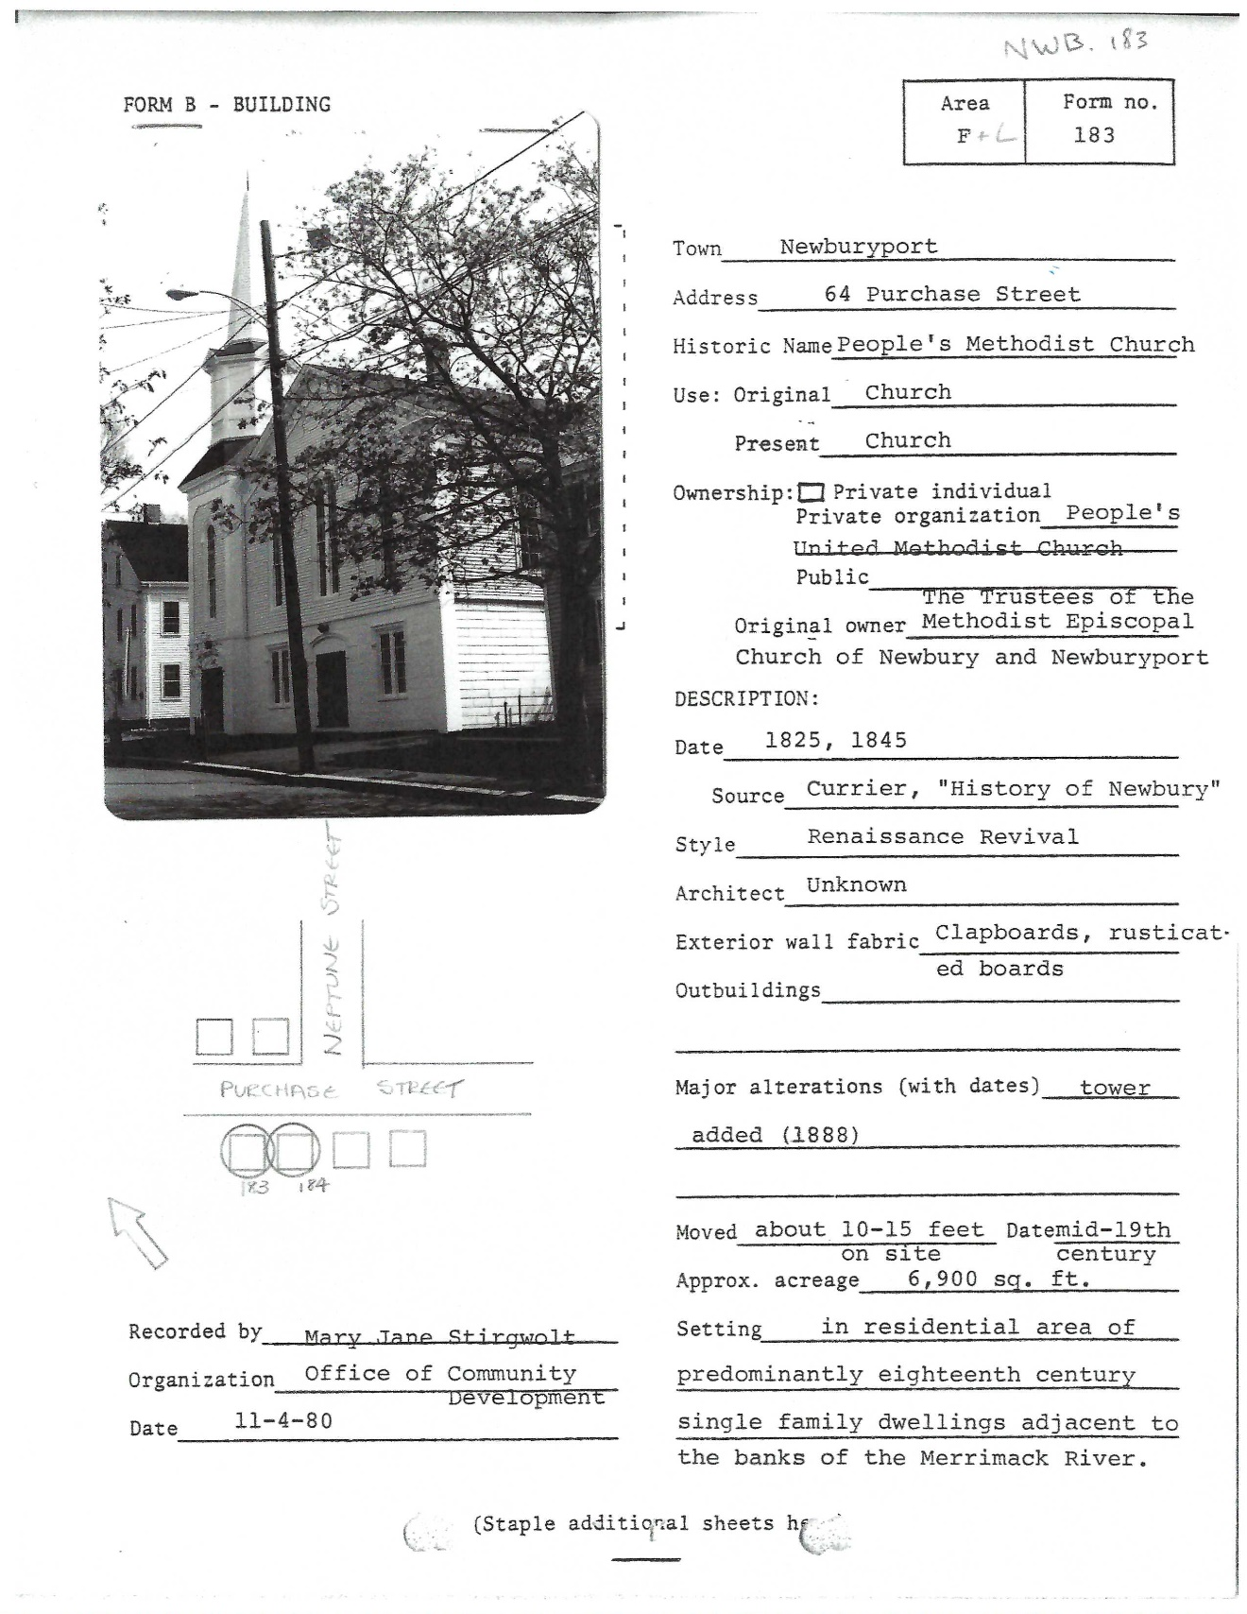

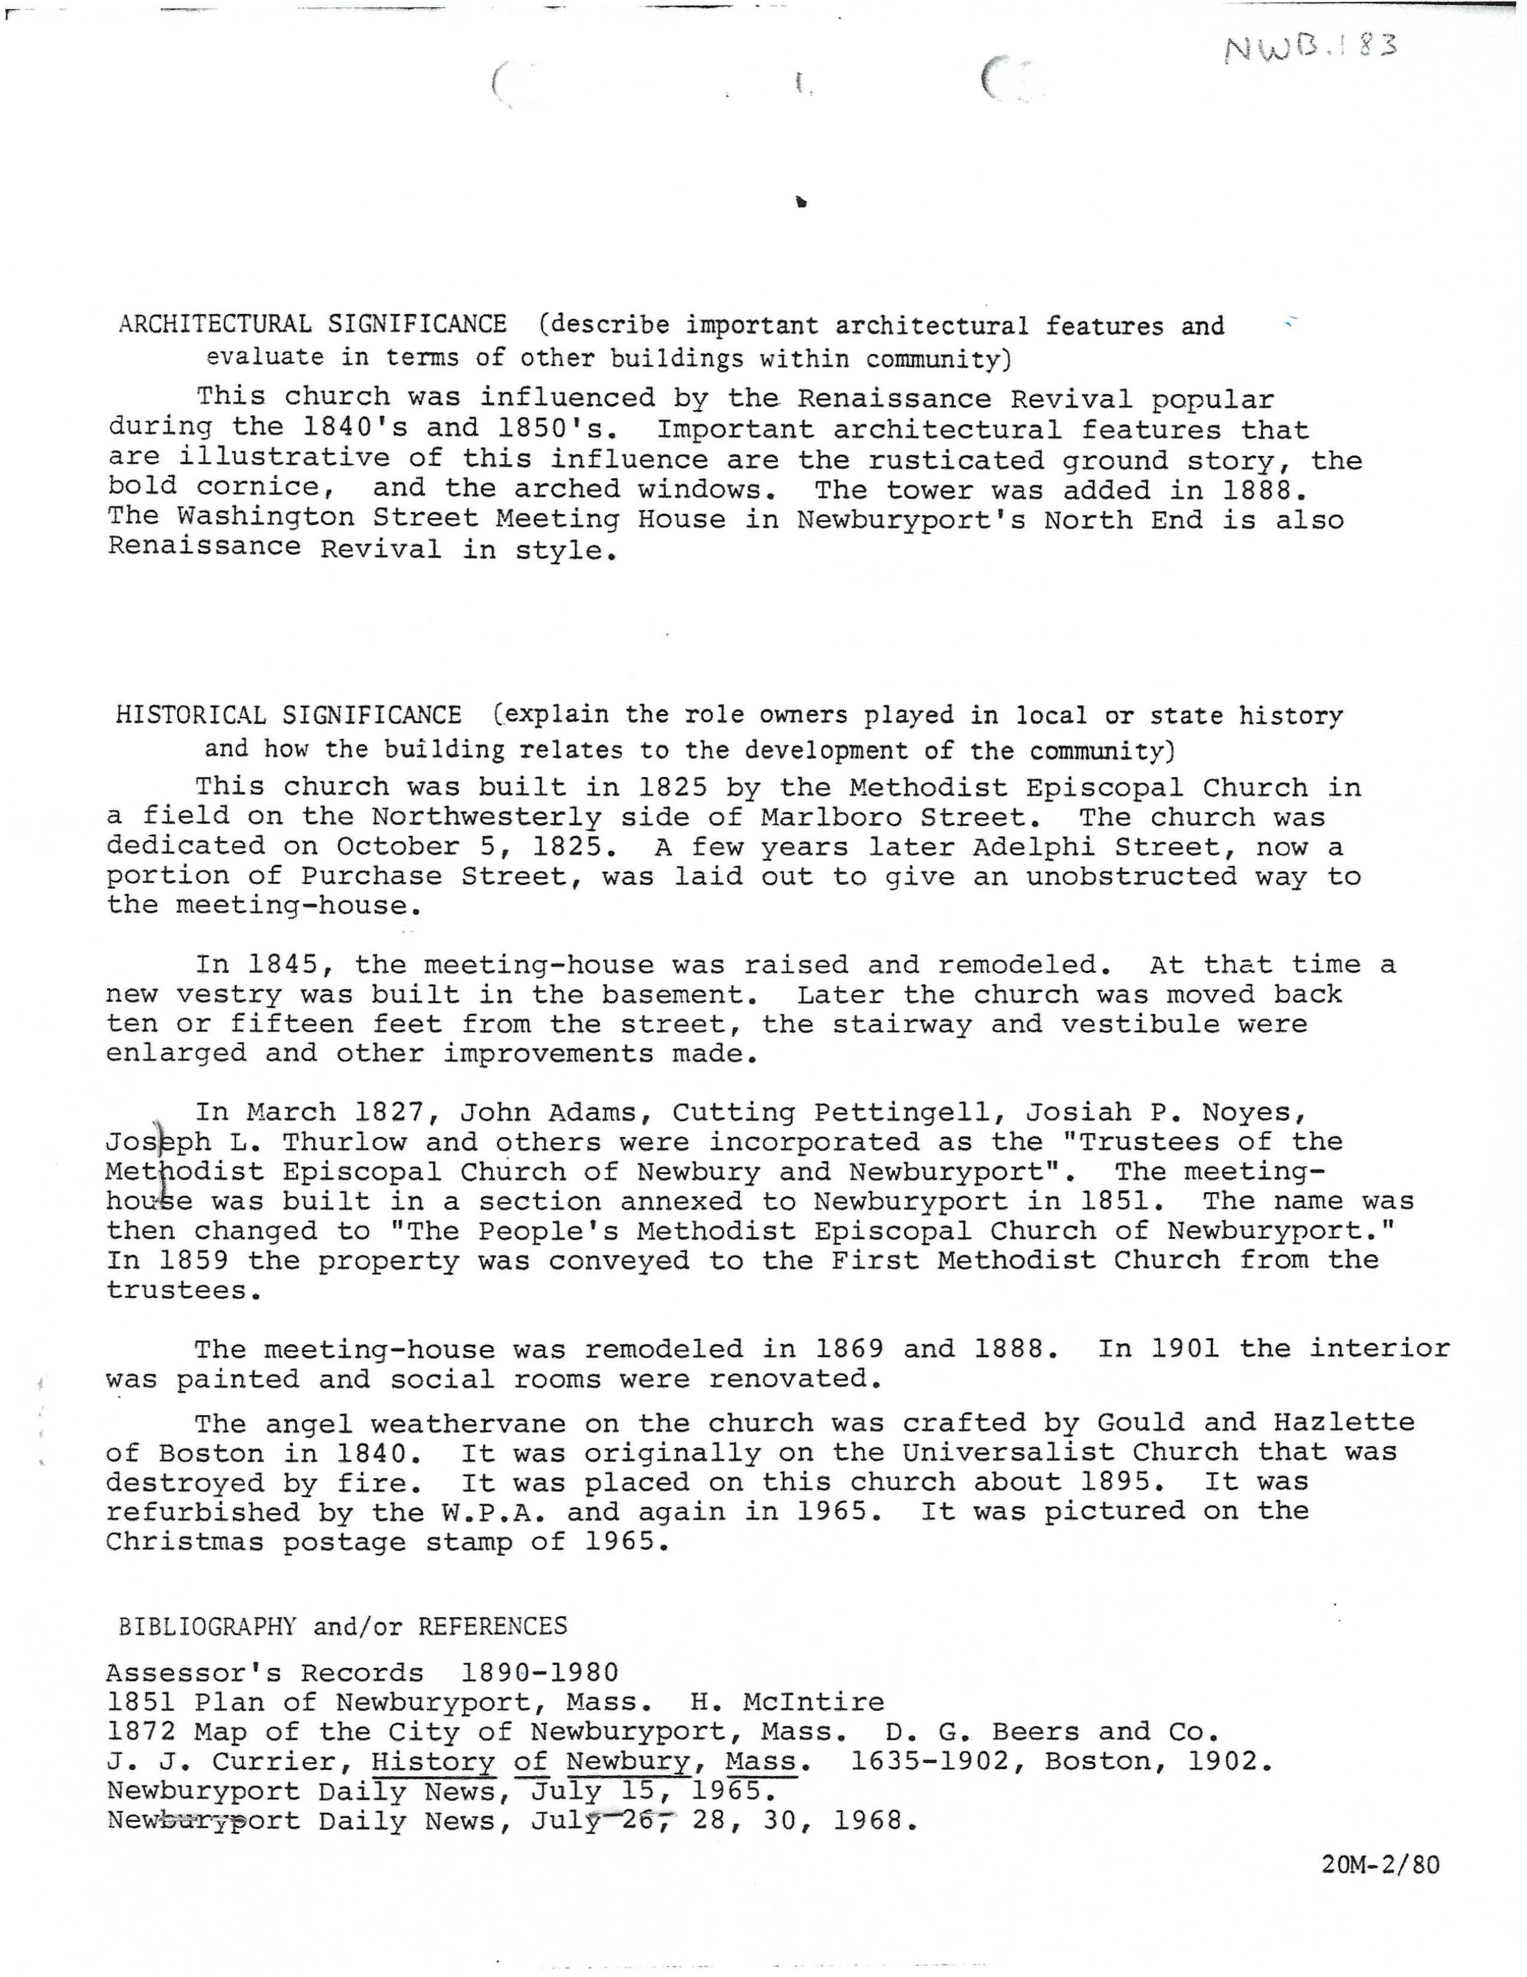

EXHIBIT D
Six (6) Photographs, taken by Novak Niketic, July 2020

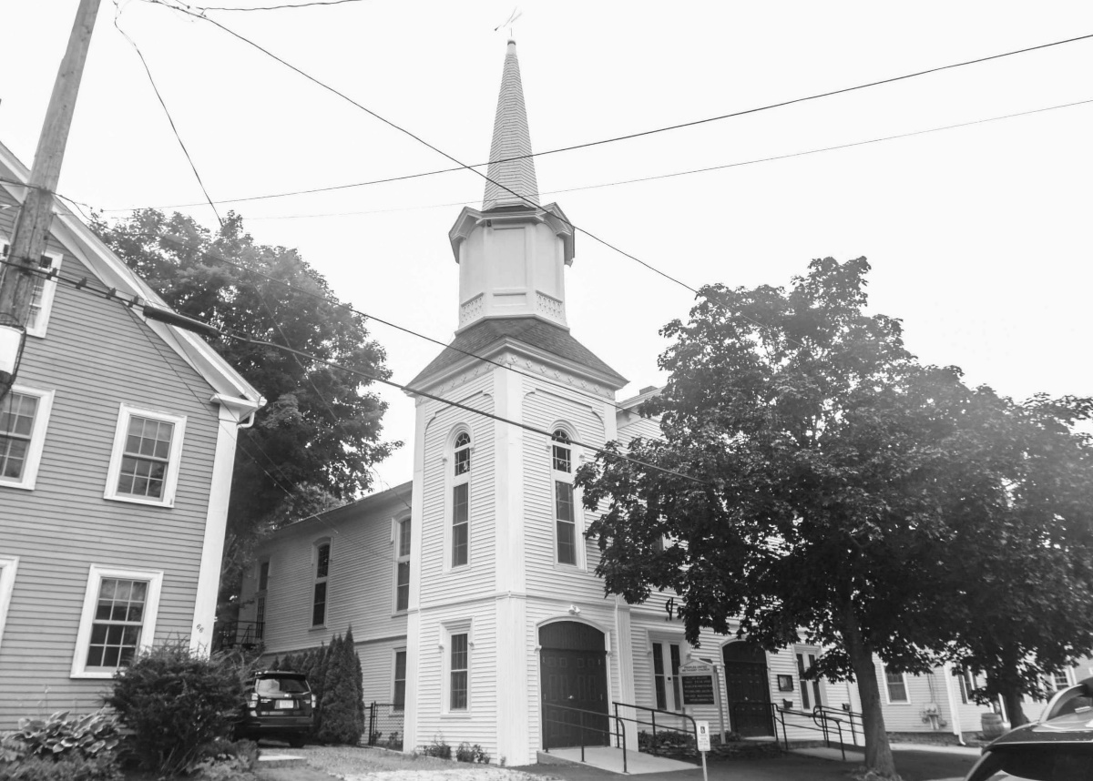
Photo 1. View of front and left (southeast) side elevations, looking west.

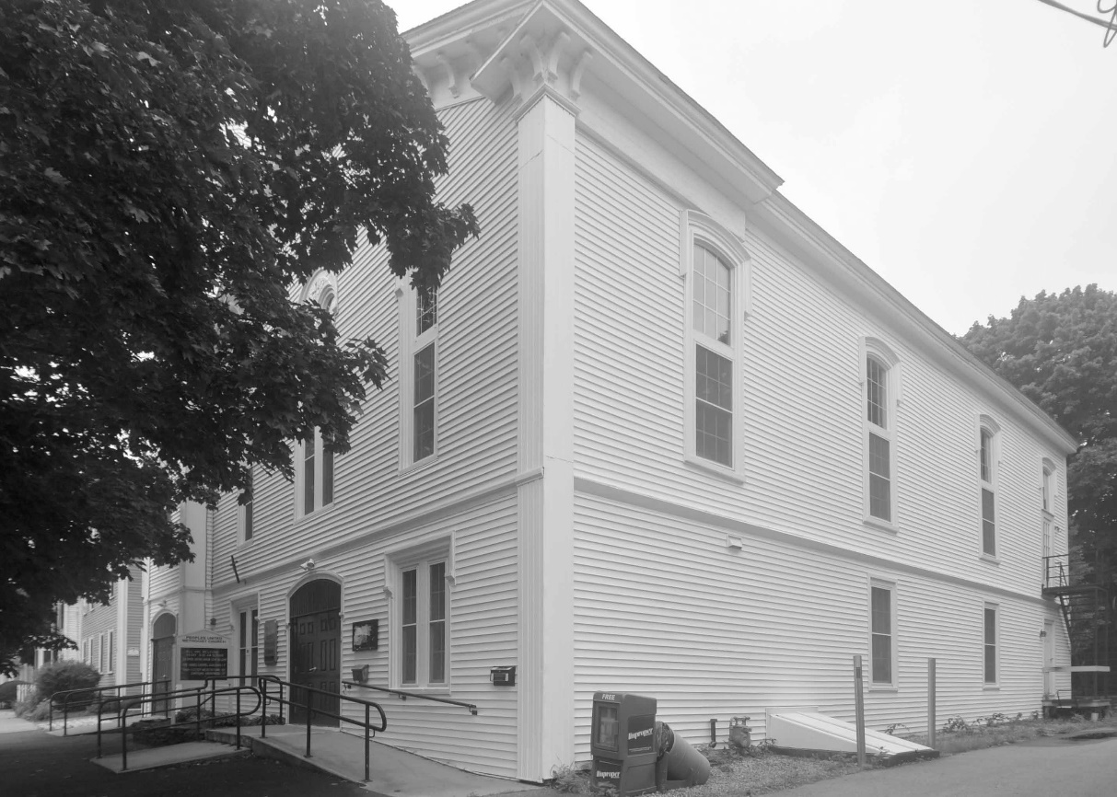
Photo 2. View of front and right (northwest) side elevations, looking east.

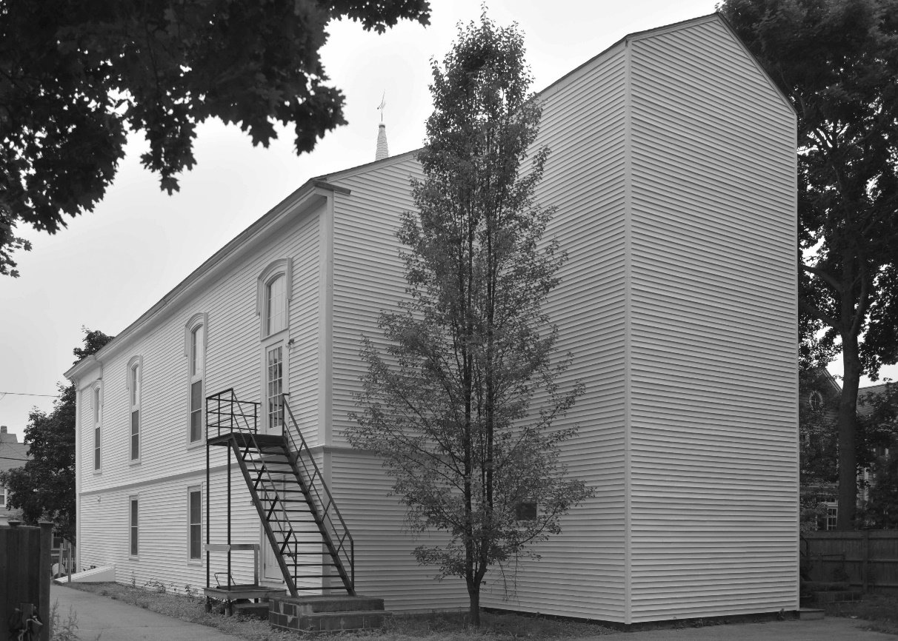
Photo 3. View of left (northwest) side elevation and rear elevation (partial) looking northeast.

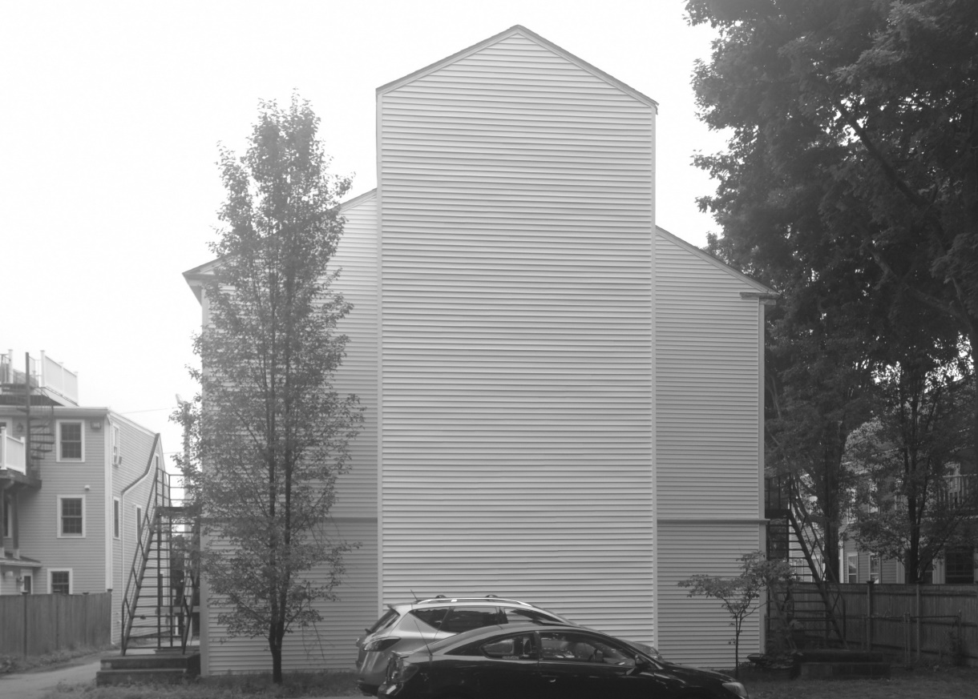
Photo 4. View of rear elevation, looking northeast.

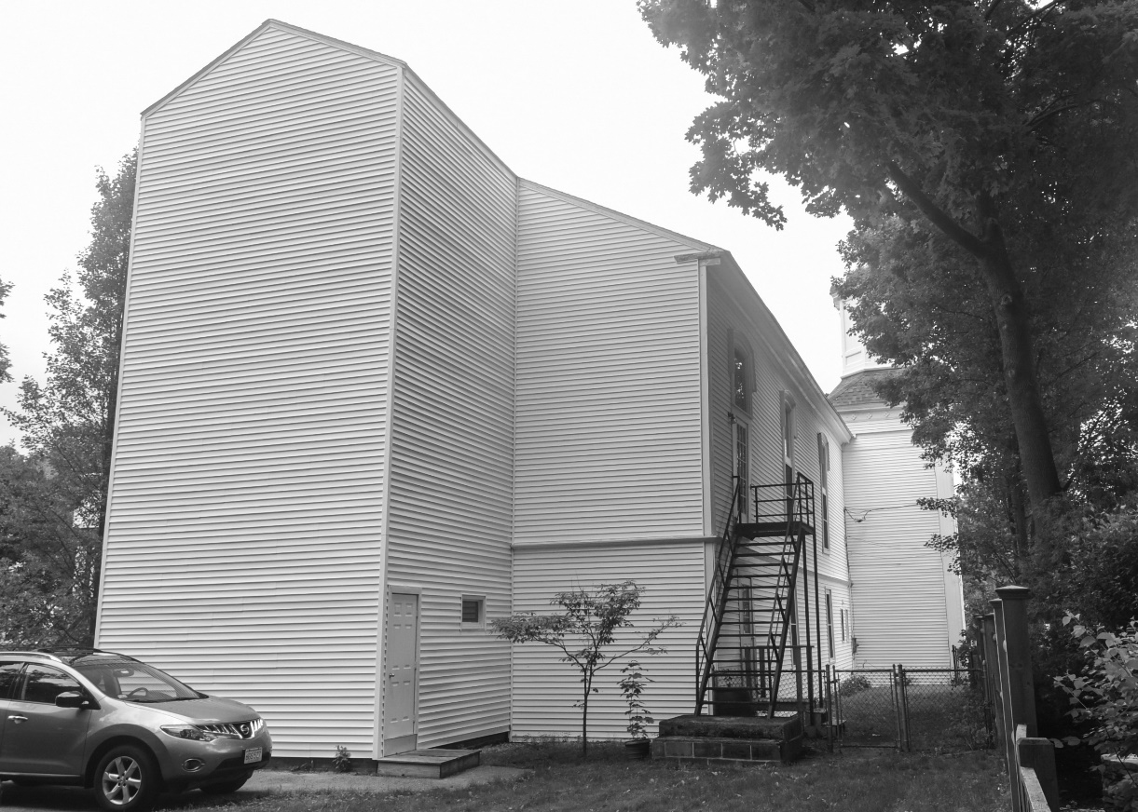
Photo 5. View of rear and right (southwest) side elevations, looking north.

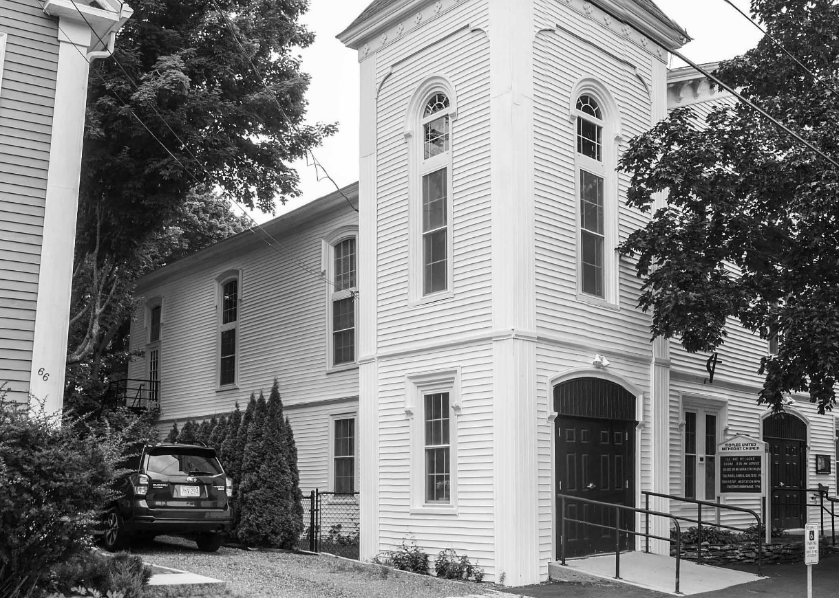
Photo 6. Detail view of front (partial) and left (southeast) side elevations, looking west.
EXHIBIT E

RESTRICTION GUIDELINES

1. PREAMBLE
The purpose of these Guidelines is to assist the Property Owner (the Grantor) and the City of Newburyport, and its designated agent, the Newburyport Historical Commission (the Grantee) in retaining the substance and character of the Building located at 64 Purchase Street, Newburyport, Essex County, Massachusetts (the Property), by establishing standards and procedures for maintenance and improvements in accordance with the principles established in this Preservation Restriction (the Restriction).

These Guidelines are not intended to freeze the Property in time but rather to provide standards and procedures to making changes. These Guidelines are administered by the Grantee. All references herein to approval by the Grantee refer to the process established in Paragraph 3 of the Restriction.

2. GENERAL PROVISIONS
In view of the importance to the City of preserving the Property's character and integrity, both with respect to the Property and in context with the surroundings, the following overall guidelines shall apply:

2.1 The Exterior appearance of the Building shall be maintained and not altered, except as otherwise provided herein. All changes must be approved by the Grantee.

2.3 Necessary reconstruction or replacement of any portion of the Building shall reproduce the existing Exterior features and components, except as specifically indicated in these Guidelines. The Building may not be elevated from its original foundation height, or have its roofline raised.

2.4 Alterations and additions shall maintain the character of the Building and shall be designed to have minimal impact on the view from the street. All changes and additions must be approved by the Grantee.

2.5 Modifications of landscaping and site features shall be in keeping with the character of the Property, subject to approval by the Grantee.

3. GENERAL REQUIREMENTS AND REVIEW PROCEDURES

3.1 Work Subject to Review
3.1.1 Approval by the Grantee is not required for ordinary maintenance and replacement of existing fabric in accordance with the Secretary’s Standards and these Guidelines. The right to maintain and repair shall mean the use by the Grantor of in-kind materials and colors, applied with workmanship comparable to that which was used in the construction or application of those materials being repaired or maintained, for the purpose of retaining in good condition the appearance and construction of the Property. The right to maintain and repair shall not include the right to make changes in appearance, materials, material colors and workmanship from that existing prior to the maintenance and repair without the prior approval of the Grantee.

3.1.2 All other non-maintenance changes and additions are subject to review by the Grantee. Approval of any proposed work must be granted in writing by the Grantee in advance of the commencement of construction.

3.2 Review Standards and Procedures
3.2.1 Review procedures, including those conducted for emergency repair and replacement, shall generally be conducted in accordance with applicable provisions of the following:

3.2.2 Secretary of the Interior's Standards for the Treatment of Historic Properties with Guidelines for Preserving. Rehabilitating, Restoring, and Reconstructing Historic Buildings (36 C.F.R. 67 and 68).

3.2.4 Determinations by the Grantee relating to work subject to review shall be based on the primary objective of retaining the substance and character of the Property, in accordance with the general provisions of Paragraph 2 of these Guidelines.

3.3 Submittal and Documentation Requirements
Material required for review may include such documentation as scale drawings, measurements, renderings, specifications, and product descriptions and samples.

3.4 Qualifications of Consultants and Contractors
3.4.1 All design work shall be performed by an architect currently licensed in Massachusetts, preferably with historical renovation and reconstruction experience.

3.4.2 All construction, except simple maintenance projects, shall be performed by contractors currently licensed in Massachusetts, preferably with a minimum of five years of experience in historical renovation and reconstruction.

4. SPECIFIC STANDARDS
The following standards are included to establish a general level of quality for all work, and are considered essential to achieve the City's primary objective for the Property.
- Building-Attached Lighting Fixtures: Light fixtures may be used but must be minimal in appearance, appropriate to the Building.
- Dormers and Skylights: Dormers and skylights are not permitted.
- Doors: Replacement of doors must be wood, and be compatible in design, color, and finish to the style of the Building.
- Exterior Trim: Existing wood trim and ornamentation must be retained, or replaced-in-kind if repair is not possible. Most of the original or historically significant trim is currently covered with synthetic siding or was removed when the synthetic siding was installed. If the synthetic trim requires replacement, the underlying wood trim must be restored if possible, and if not, must be replaced-in-kind. Synthetic trim may not be replaced-in-kind.
- Landscape features: Fences or other hardscaping that obscures the Building from view from the street is not permitted.
- Mechanical Equipment: Window mounted HVAC or other ventilation equipment are not permitted. Openings made for HVAC or other equipment on the exterior of the Building must be located in a manner that does not detract from the Building.
- Paint: Changes in exterior paint colors must be historically appropriate and must be approved by the Grantee.
- Roofing: The main roof is clad in medium gray asphalt shingles. If the current shingles require replacement, they may be replaced-in-kind. It is encouraged that they be replaced with the original shingle material and pattern if that material and pattern can be determined by photographic or other documentation. The wood shingles on the tower spire must be repaired or replaced-in-kind.
- Siding: Most of the original or historically significant siding, including rusticated boards on the lower level and wood clapboard on the upper level, is currently covered with synthetic siding or was removed when the synthetic siding was installed. If the existing synthetic siding requires replacement, the underlying wood siding must be restored if possible, and if not, must be replaced-in-kind. Synthetic siding may not be replaced-in-kind.
- Storm windows: Storm windows may be allowed provided they match the color of the underlying window surround and the meeting rails align with the meeting rails of the window sash.
- Windows: Existing windows are all replacement of the original wood windows. If the current windows require replacement, they must be replaced with true-divided wood windows with the original muntin patterns as determined by photographic or other documentation.

