Examples of historic buildings the NHC would like to properly document include the houses in the Ocean Mills Historic District, a collection of mid-to-late 19th-century millworkers’ houses ranging from simple rectangular gable-roofed houses to Greek Revival and Victorian vernacular cottages with ornamented doorways and eaves. These small houses were built on pastureland near the Ocean Mills factory, with some retaining roomy back yards, and lived in by workers employed at the Ocean Mills factory, in the shoemaking industry, and at Towle Silversmiths. The houses on 7-19, 22-40 and 47-51 Carter are of particular interest. These Greek Revival houses at 49 & 51 were likely owned by skilled craftsmen or mill agents, as they are both more ornate and closer to elegant High Street. It is remarkable that most of the houses on Carter and Ocean streets have retained their form and profile and have not been over-expanded or burdened with dormers.

. 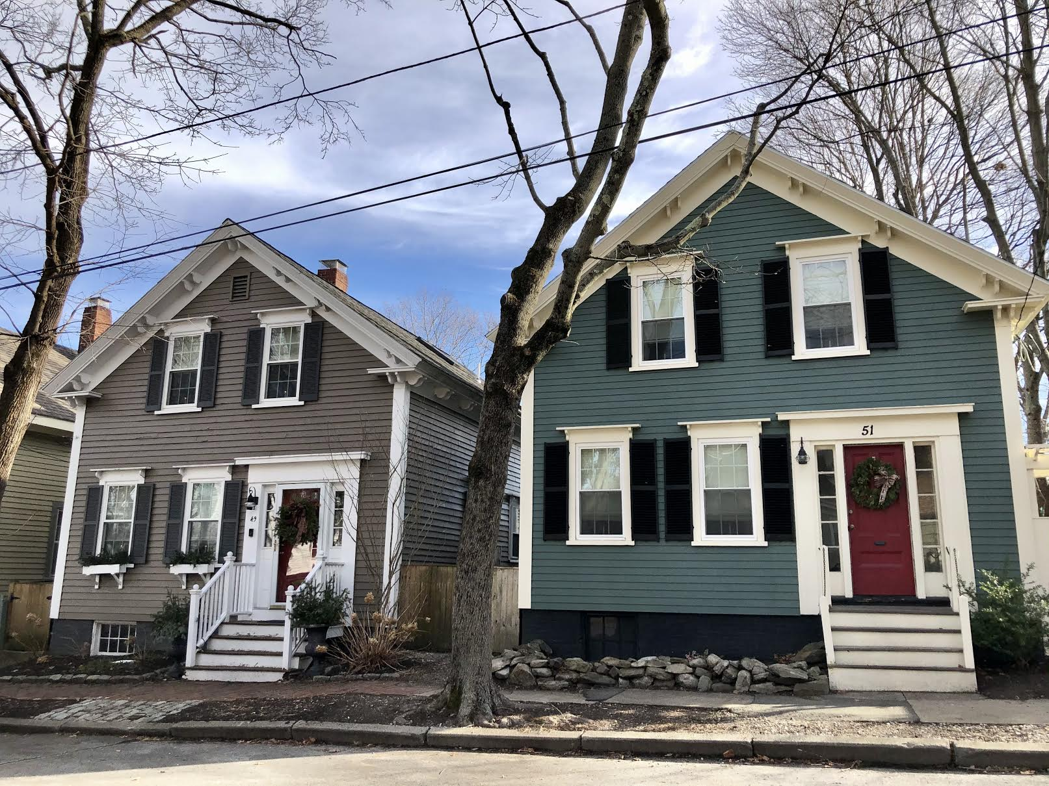

Ideally, all 18th-century houses could be captured in the survey, including those that are listed in the District Data sheets but do not have Form Bs – for example, the c. 1730 Joseph March House, a central-chimney ¾ house at 26 Federal Street, and its neighboring c. 1730 Jonathan Sampson House , a central-chimney gambrel at 64 Liberty Street. These houses, close to the wharves, were inhabited by skilled tradesmen (cooper, caulker).

