ODNC 051 02-24-2020

ORDERED:

AN ORDINANCE TO AMEND ARTICLE XXVII (Downtown Overlay District) of THE Newburyport ZONING ORDINANCE As to Fences and Site Walls

Be it ordained by the City Council of the City of Newburyport as follows:

THAT Sections XXVII-E and XXVII-F of the Zoning Ordinance be amended pursuant to Section XII-B (Adoption and Amendment) to read as follows, with deletions double stricken-through and in bold, and additions double-underlined and in bold:
XXVII-E - Exclusions.
Consistent with the city's intent for the DOD under subsection XXVII-A, a DOD-SP shall not be required for any of the following categories of work, which are hereby excluded from review by the SPGA under this section, upon a written determination by the zoning administrator:
…
- Any (i) alteration, demolition, or replacement of windows, doors, signs, and/or awnings, or (ii) construction, alteration, demolition, or replacement of fences or site walls, that is reviewed and approved by the office of planning and development under subsection XXVII-F.5(d);
…
XXVII-F Procedure and criteria.
…
- Procedure, requirements, and criteria for review of proposed new construction and alterations:
…
- Staff-level review: The office of planning and development may review and approve for consistency with this section (i) the proposed alteration, demolition, or replacement of windows, doors, signs, and/or awnings, and (ii) the proposed construction, alteration, demolition or replacement of fences or site walls, when such work is unaccompanied by any other work subject to this section over a period of three (3) consecutive years, in which case exclusion 3 shall apply under subsection XXVII-E and no DOD-SP shall be required. Notwithstanding the foregoing, any proposed new window or door opening in an external wall of an historic building or structure for a window or door, and any proposed new, altered, or replaced fence or site wall higher than five feet (5’-0”) shall require a DOD-SP.
…
- Fences and site walls: New fFences and site walls anywhere within the DOD, whether newly constructed, altered, or replaced, require either staff-level review and approval by the office of planning and development or a DOD-SP. All such fences and site walls shall be appropriate in scale, materials and architectural style to the historic buildings and structures located on the same lot, to the lot itself, and to its setting. Fences or site walls that will be visible from a public way, public park or playground, or the Merrimack River warrant additional scrutiny for appropriateness, as provided herein. New fences and site walls shall not substantially block significant views from any street, way, public park or playground, or the Merrimack River, of the primary facades of historic buildings and structures located within the DOD. Placement of fences and site walls along lot lines confirms historic lot patterns of neighborhoods, as opposed to placement along arbitrary lines, and is favored. Wood, wrought-iron, masonry, or other historic materials shall be used instead of plastic, vinyl, aluminum, or other contemporary materials. Where a more ornate style of fencing or site walls can be documented as having been present at the subject property, then such historic style may be replicated. In other cases, simpler historic designs, such as wood-picket, wrought-iron, or masonry shall be used instead of contemporary styles, such a unfinished, pressure-treated lumber, dog-eared, or chain-linked fencing. Fences and site walls shall be at a height from grade that is proportional to the structure(s) they accompany and the area they enclose, and, if within the required front yard setback, shall not be taller than three feet (3’-0”) unless the visible surface area of such fence or site wall has a porosity of at least fifty percent (50%). In all cases, solely the SPGA may approve heights in excess of five feet (5’-0”) for those fences or site walls visible from a public way, public park or playground, or the Merrimack River.
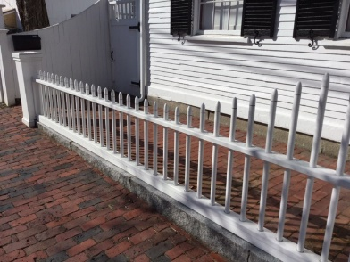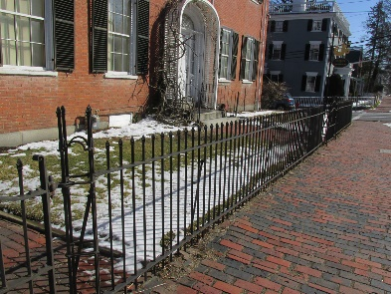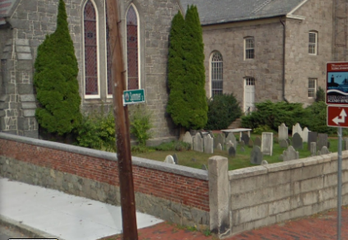
(Simpler historic fence and site wall designs.)

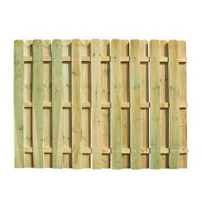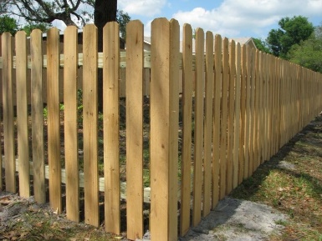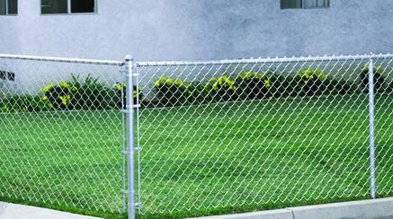
(Unacceptable contemporary fence and site wall styles.)

_______________________
Councillor Jared J. Eigerman

