Museum of Old Newbury
Full Electrical System Renovation:
Purpose, Specifications and Notes
January 31, 2020

Purpose:
The Museum of Old Newbury’s main building located a 98 High Street is in major need of a complete electrical system replacement. Significant portions of the system are estimated to be more than 75 years old with some portions approaching 100 years. The age, coupled with total lack of electrical code compliance, presents serious concerns regarding fire danger, electrical system failures and in inability to support modern electrical loads. These issues also have significant impact insurance underwriting and costs. This document, along with accompanying floor plans, details the work to be done to bring the building up to 21st century electrical and safety standards.

Electric service, entrance and distribution panels
Service: 200 AMP, 220VAC
Entrance: Current entrance, upgraded conduit with entry either above basement ceiling or below basement floor.
Entrance Panel: Location in HVAC/Electrical Room. If code requires a master cutoff switch due to long interior run we would prefer an exterior underground conduit run to exterior location closest to entrance panel.
Distribution Panels: 3 distribution panels located is designated electrical closets on 1st, 2nd and 3rd floors using vertical risers. Three designated closets are directly over one another. First floor panel must be able to support fully equipped kitchen and 3rd floor panel must be able to support future third floor and top knot HVAC.
Please note that the building currently has an electromagnetic whole house disconnect for fire prevention reasons. The only circuits that remain active are HVAC, security and fire alarms. It is anticipated that this system will be duplicated in the renovation.

House Wiring
Complete replacement of existing wiring, current lighting (fixtures are to be selected by curator, all fixtures are to be LED) as well as addition of 110VAC outlets, new gallery lighting, security system provisions and fire detection. All new location outlets are to be installed in the floor using spec’d floor outlets. Existing outlet boxes need to be replaced with code acceptable boxes and new outlets.
It is believed that wiring from each floor’s wiring closets can be installed with a minimum of infrastructure disturbance by lifting floorboards on the second and third floors. First floor access is from the basement and third floor ceiling lighting is from the attic. Where lighting is to be switched, wireless technology is to be used to avoid wall disturbance.
Existing stair hall ceiling lighting is not shown on the plans as they are in fixed locations.
Basement: Basement is to be wired as per plan. Ceiling is to be removed in the lecture hall to facilitate access to first floor wiring, sub panel distribution and basement wiring. All basement outlets are to be 20 AMP 110VAC. Lighting in lecture hall, future document room is to be LED 2x2 panels, 40W, dimmable and color tunable using remotes. Contractor should provide three spare LED panels as well as uninstalled panels for future document room. Track light for lecture gallery and grotto room should be museum grade LED lighting selected by curator. Other lighting for HVAC room, lavatories and stair halls should be appropriate lumens with a color temperature no more that 3000K. Although not shown on plans the stairwells and exterior entrances on the rear of the building are to be rewired and fitted with curator selected fixtures on both the interior and exterior. Additional fixtures maybe required to insure adequate/safe stairwell/stair hall lighting meeting best practices.

First Floor: To be wired to plan. Existing outlets are to be rewired with new outlets and covers. Added outlets are to utilize in-floor outlets (see specs) spaced appropriately to avoid structural members. Each room should have a minimum of 2-15 AMP outlets. Dining room display closet should be rewired and relighted using lighting selected by curator. Existing switches need to be rewired and ceiling fixtures need to be rewired and sockets need to be replaced as appropriate including dining room chandelier (should be dimmer controlled). Although not shown on plans exterior entrances need to have lighting replaced and rewired. New security system panels need to be installed by front door and Fruit St entrance door and the fire security panel needs to be replaced or eliminated if acceptable. Kitchen is to be wired to code able to support electric range, microwave, dishwasher and refrigerator. Switches, outlets and lighting needs replacement as well, and will be selected by curator.
Second Floor:
To be wired to plan. Existing outlets are to be rewired with new outlets and covers. Added outlets are to utilize in-floor outlets (see specs) spaced appropriately to avoid structural members. Each room should have a minimum of 2-15 AMP outlets. Existing switches and ceiling fixtures need to be rewired and sockets need to be replaced as appropriate.
Gallery track lighting is to be installed all rooms on the second floor in the same fashion as in the Hills Gallery. This lighting should be as unobtrusive as possible and meet all art museum requirements. Lighting style shall be selected by the curator.
Silver Room requires complete rewiring and cases require relamping. Specific color temperature LED lighting will be determined by curator.
Third Floor:
To be wired to plan. Existing outlets are to be rewired with new outlets and covers. Added outlets are to utilize in-floor outlets (see specs) spaced appropriately to avoid structural members. Each room should have a minimum of 2-15 AMP outlets. Existing switches and ceiling fixtures need to be rewired and sockets need to be replaced as appropriate.

Top Knot:
To be wired to plan. Existing outlets are to be rewired with new outlets and covers. Stair wells should have safety lighting installed with appropriate switches at stair bases. All unidentifiable wiring in the attics should be removed or replaced as required.

Building Security
Concurrent with the wiring work the Museum will be installing an upgraded state of the art security system. This will reduce disruption to the house infrastructure and the need to duplicate wiring effort. Electrical contractor should be prepared to coordinate with security provider.
Fire Alarms
Replacement of existing alarm heads as well as the addition new heads per plan and in attic areas. In addition, gas alarms and CO detection alarms are required. Lastly, water detection alarms are required in the basement. Electrical contractor to work with fire department for appropriate location of alarm heads, relocation of fire alarm call system,

Description

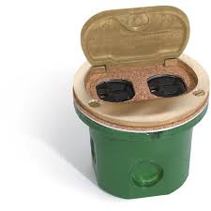

Specifications
Cover: Brass
Outlet: 1 duplex 15A tamper proof
2 flip lids
Flush mount into floor
Box UL # 514A, cUL 22.2 #18.1-04
Outlet UL # E333616
Several knockouts for conduit
Includes plate screws
Cover size: 4" round
Hole size: 3.5" round
Depth: 3.14" deep
Capacity: 14.5 cubic inches
Warranty: 1 year
Lew Electric 812-DFB-LR Drawing (PDF)
Lew Electric 812-DFB-LR Installation Instructions (PDF)

2X2 CCT Adjustable LED Panel 2-pack
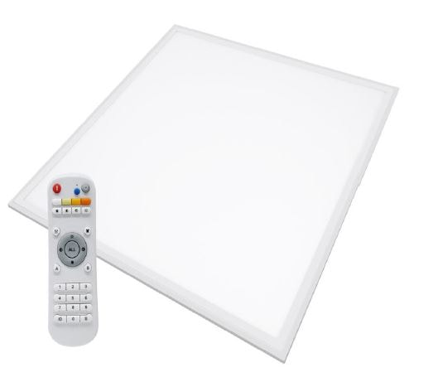
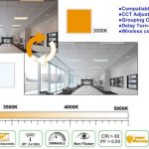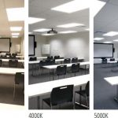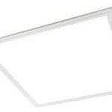
Be the first to review this product

2X2 CCT Adjustable LED Panel 2-pack
$153.00
This CCT Adjustable 2×2 LED panel light can replace the equivalent of 100W fluorescent tubes, saving you up to 80% in energy consumption. In addition to the significant savings in energy, these panel lights also have a lifespan of over 50,000 hours.
LED panels are UL, DLC, CE, ROHS approved, and we offer a 5 year limited warranty.
This flat panel light is designed with the simplest and quickest installation method in mind. Easily fits into existing T-grid systems. Flat Panels can be recessed, suspended, or surface mounted.
FUNCTIONALITY- These LED ceiling panels feature state of the art dimmable LED technology that work with any 0-10V dimmer, along with a remote for color tuning.
These LED ceiling lights are designed for commercial suspended grid ceilings. They can be used for office lighting, gym lighting, school lighting, hospital lighting, and more!
114 in stock (can be backordered)

Add to cart

SKU: SE28Category: Color Tunable LED Panels
MODEL | PLR-40W-66
POWER | 40W
LUMENS | 4,280 LUMENS
INPUT VOLTAGE | 120-277VAC
POWER FACTOR | >.95
COLOR TEMP | adjustable-3000K-5000K
CRI | RA80
RATED LIFE | 50,000 HOURS
CERTIFICATIONS | DLC 4.2 & UL
Spec Sheet
CCT Adjustable LED Flat Panel-PLR-66-40w, PLR-50W-126, PLR-40W-123
This CCT Adjustable 2×2 LED panel light can replace the equivalent of 100W fluorescent tubes, saving you up to 80% in energy consumption. In addition to the significant savings in energy, these panel lights also have a lifespan of over 50,000 hours.
LED panels are UL, DLC, CE, ROHS approved, and we offer a 5 year limited warranty.
This flat panel light is designed with the simplest and quickest installation method in mind. Easily fits into existing T-grid systems. Flat Panels can be recessed, suspended, or surface mounted.
FUNCTIONALITY- These LED ceiling panels feature state of the art dimmable LED technology that work with any 0-10V dimmer, along with a remote for color tuning.
These LED ceiling lights are designed for commercial suspended grid ceilings. They can be used for office lighting, gym lighting, school lighting, hospital lighting, and more!

