129 Route 125, Kingston, NH 03848
Tel: 603.642.8300 Fax: 603.642.8500
Seekamp Environmental
Consulting, Inc.

Project Narrative

for
Gregory Elliott
&
Candace McMahan
(applicants)

for a property at

12 54th Street
Newburyport, Massachusetts
2/25/20
(Revised 4/28/20)
Proposed project

The proposed project involves the addition of a screened in porch that will be supported by beams suspended between existing house and deck columns. There will also be a second floor added to the existing house. The existing home is on a Barrier Beach/Coastal Dune, Plum Island.

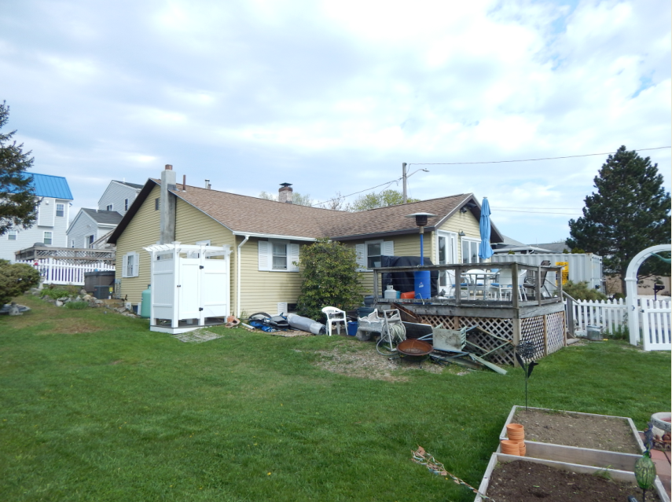
Existing conditions. This view shows the gap between the existng deck and the west facing wall of the building where the addition is proposed.

Elevation rule
The elevation of the proposed replacement support members is greater than two feet above the base flood elevation and the highest ground elevation in those areas. See photographs below.
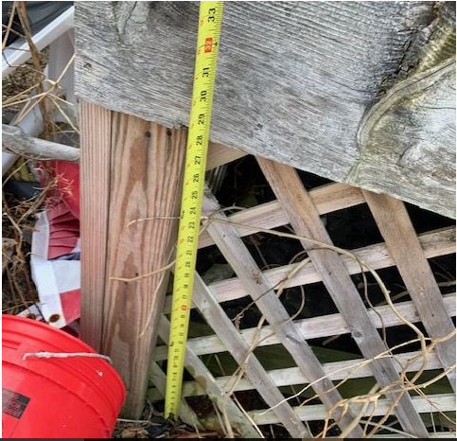
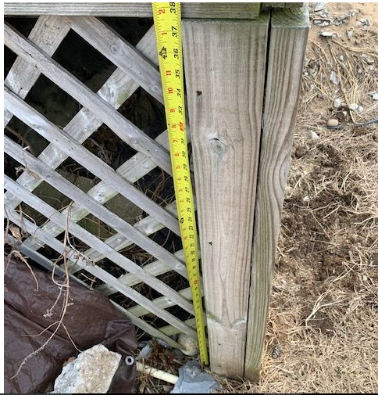

The area below the lowest support beam will remain open. There will be no on-the-ground impacts (other than shadowing) resulting from the proposed addition.

Mitigation:
An equal area (129 sq. ft.) will be planted with Beach Grass (Amophila breviligulata) with a density of three culms per hole spaced 18 inches to 24 inches apart; a total of 172 culms in the area cross hatched in red. This area is currently un-vegetated and covered in gravel area.
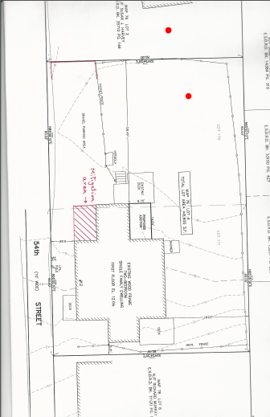

25% - 50% Rule
The area being added to the footprint of the living space of the existing building is less than 25% of the existing living space. The cost to the renovation is less than 50% of the value of the existing dwelling. We have provided an analysis of these assertions with this application.

Michael Seekamp
Senior Wetland Scientist

