- Please visit www.cityofnewburyport.com.

- On the home page, you will see six circular icons near the top of the page. Here’s what it looks like:

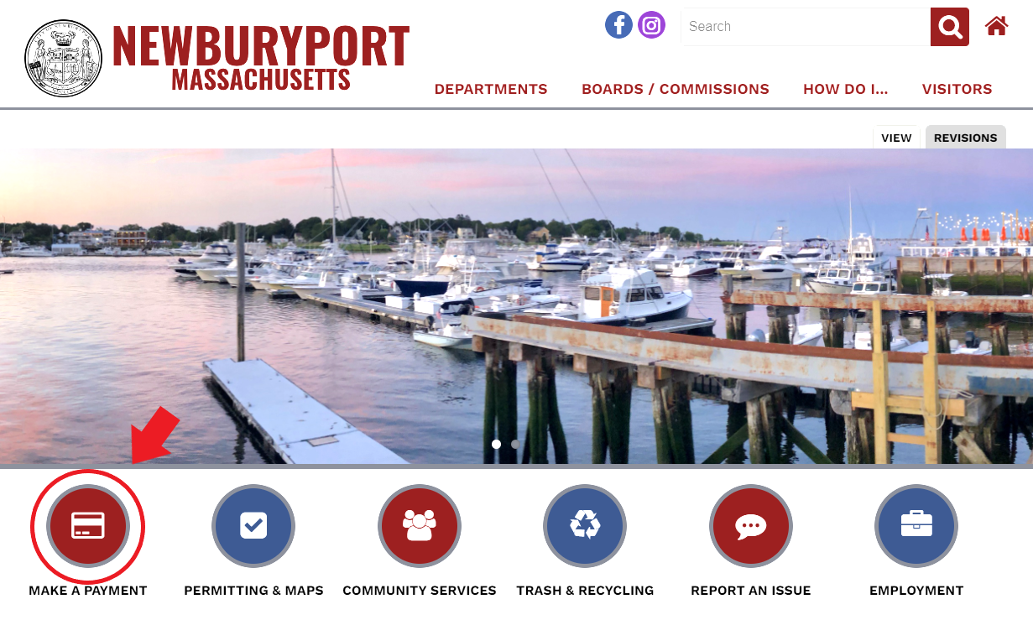
- You will want to select MAKE A PAYMENT as shown in the picture above.

- You will then be led to the Online Payments Center webpage. Here you will find a list of permits, payments, etc. that can be paid for online. Locate Yard Waste Stickers under the Payment Type header and click on ORDER NOW! directly to the right.

- You will come to another page titled Welcome to the City of Newburyport Recycling Department’s Online Payment Center where, on the left, you will see the YARD WASTE STICKERS option under the Transactions header.

- Once you click on the transaction type, you’ll be brought to the application that you need to fill out. NOTE: please be sure that you know your car’s license plate number. Additionally, there are two different ways to pay online:
  - Credit/Debit: there will be a small transaction fee of $2.50 when using a credit/debit card on UniPay.
  - Check: if you happen to know your routing number and bank account number (located on your check), you can skip over the $2.50 fee.

- Once you’ve filled out all the necessary fields, it will ask you to confirm your order several times throughout the process.

- IMPORTANT: UniPay will ask if you want to create an account. You do not need to sign up or give any of your information. To the bottom right, you will find text that says Sign Out As Guest. You will want to select that option to continue.

- Once you are finished providing your information and you submit your application, you will receive an email of an electronic receipt.

