CITY OF NEWBURYPORT

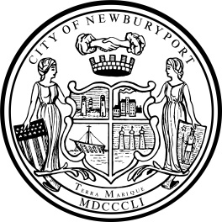 IN CITY COUNCIL

ORDERED:

June 13, 2022

THAT, The CITY COUNCIL of the City of Newburyport accepts with gratitude a gift from Make A Wish Massachusetts-Rhode Island in the amount of $9,453.74 for the purpose of planting trees and installing one bench on the Clipper City Rail Trail. Said funds are deposited into the Parks Gift & Donations Account and accepted in accordance with M.G.L. Chapter 44, Section 53A.

___________________________________
Councillor Sharif I. Zeid

