CITY OF NEWBURYPORT
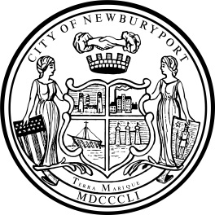 IN CITY COUNCIL

ORDERED:

April 11, 2022
WHEREAS, a photovoltaic solar electric generating facility has been proposed by a Developer, BWC Artichoke Reservoir, LLC, to be constructed on privately-owned property consisting of approximately 6.75 acres of land located at 36 Colby Farm Lane, Newburyport, MA, 01950, as more particularly shown on Assessor's Map 99, Lot 3, and more commonly known as the “Landfill”;
WHEREAS, clause 45 of M.G.L. c. 59, § 5, as affected by Sections 61 and 63 of Chapter 8 of 2021 (“An Act Creating a Next-Generation Roadmap for Massachusetts Climate Policy”), allows cities and towns to enter into an agreement for payments in lieu of taxes (PILOT) with the owner of a solar or wind powered system or energy storage system, or a combination of the same;
WHEREAS, it may be in the best interests of the City and the Developer to enter into an agreement fixing the payments that will be made with respect to all taxable property incorporated within the project for the term of the agreement; and
WHEREAS, if a PILOT agreement is desired, the municipality is required to act through “its authorized officer,” which is one given authority by the municipality’s legislative body to negotiate the PILOT agreement, to include the chief executive officer (CEO) of the municipality (selectboard, mayor or manager), or some other combination of municipal officer or officers;
NOW, THEREFORE BE IT ORDERED, THAT, the City Council of the City of Newburyport hereby authorizes the Mayor, acting with the Assessor, Finance Director and Sustainability Director, to negotiate a PILOT agreement with BWC Artichoke Reservoir, LLC, subject to further approval by the City Council prior to executing said agreement.

___________________________________
Councillor James J. McCauley

In City Council April 11, 2022:
Motion to refer to Planning a& Development by Councillor Zeid, seconded by Councillor Cameron.
So voted.

