CITY OF NEWBURYPORT
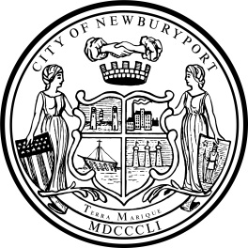 IN CITY COUNCIL

ORDERED:

March 28, 2022

THAT, at the recommendation of the American Rescue Plan Act (ARPA) Ad Hoc Committee, $100,000 is hereby appropriated from the City’s allocation of the Coronavirus State and Local Fiscal Recovery Funds (SLFRF) to pay costs of replacing and stabilizing the walkway, which runs along the Joppa Park sea wall, including the installation of accessible paver aprons that are needed to bring the park into compliance with the Americans with Disabilities Act (ADA) standards. It is the intent that any funds remaining upon completion of this project shall be reappropriated to another project as recommended by the ARPA Ad Hoc Committee.

___________________________________
Councillor Bruce L. Vogel

___________________________________
Councillor Christine E. Wallace

In City Council March 28, 2022:
Motion to refer ORDR00333, ORDR00334, ORDR00335, and ORDR00336 collectively to Budget & Finance by Councillor Zeid, seconded by Councillor Cameron. So voted.

