CITY OF NEWBURYPORT
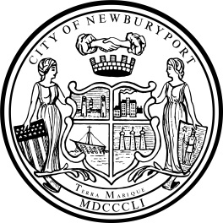 IN CITY COUNCIL

ORDERED:

March 28, 2022

March 24, 2022

THAT, the City Council of the City of Newburyport hereby approves and authorizes the Mayor of the City of Newburyport to enter into a lease with the Friends of Plum Island Light, Inc. relating to the Lighthouse and surrounding premises located at 263 Northern Boulevard, Newburyport, MA for a period of ten years commencing on May 1, 2022. Said lease is attached hereto and incorporated herewith and marked attachment ‘A’.

___________________________________
Councillor McCauley

___________________________________
Councillor Zeid

In City Council March 28, 2022:
Motion to refer to Planning & Development by Councillor Zeid, seconded by Councillor Cameron. So voted.

