Andrew B. Casson, Chairman
James Knapp, Secretary
Justin Dutcher
Robert Dow
Chris Kealey Daniel May
Paul J. Rooney, Jr.

Paul Hogg, Harbormaster

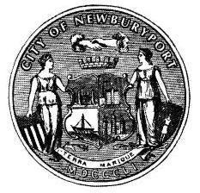
CITY OF NEWBURYPORT HARBOR COMMISSION

April 13, 2017

Time: 7:00 pm
Place: Harbor Master & Transient Boaters Facility

Agenda
(i = for information, a = for action)

Time (e) 7:00 pm  7:00 pm | Type (a)  (i/a) | Duration (e) 00:00  00:05 | Speaker  Andrew Casson All | Description Call to Order  Review and approval of draft
minutes for HC meeting of
March 9, 2017
7:05 pm  7:35 pm  8:05 pm | (i/a)  (i/a) | 00:30  00:30  00:15 | All  All  All | Subcommittee Assignments  General Discussion  Subcommittee Updates
8:20 pm | (i) | 00:15 | Paul Hogg | Harbormaster’s Update
8:35 pm | (a) | 00:00 | All | Adjournment

60 PLEASANT STREET • P.O. BOX 550, NEWBURYPORT, MA 01950 • (978) 465-4400 • (978) 465-4452 (FAX)
WWW.CITYOFNEWBURYPORT.COM

