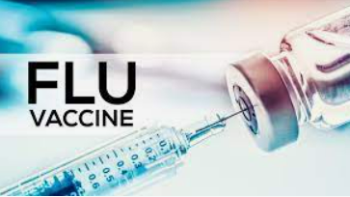

FLU CLINICS (18+)

Influenza key points (from CDC https://www.cdc.gov/flu/weekly/)
- Seasonal influenza activity is high and continues to increase across the country.
- CDC estimates that, so far this season, there have been at least 8.7 million illnesses, 78,000 hospitalizations, and 4,500 deaths from flu.
- The majority of influenza viruses tested are in the same genetic subclade as and antigenically similar to the influenza viruses included in this season’s influenza vaccine.
- An annual flu vaccine is the best way to protect against flu. Vaccination helps prevent infection and can also prevent serious outcomes in people who get vaccinated but still get sick with flu.
- CDC recommends that everyone ages 6 months and older get a flu vaccine annually. Now is a good time to get vaccinated if you haven’t already.
- The MA Dept of Public Health tracks influenza severity and ranges from low, moderate, high, to very high. Recently the influenza severity has been in the VERY HIGH range.

Upcoming FLU Vaccine Clinic 18+

Senior Center
December 15th, 1pm-7pm
https://home.color.com/vaccine/register/newburyport?calendar=8b2c9187-96ce-400e-9442-6f1c2609f1ae

