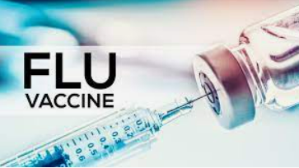
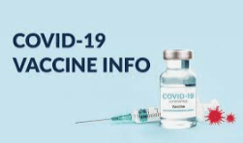

FLU and COVID CLINICS

Influenza key points (from CDC https://www.cdc.gov/flu/weekly/)
- Seasonal influenza activity is high and continues to increase across the country.
- CDC estimates that, so far this season, there have been at least 8.7 million illnesses, 78,000 hospitalizations, and 4,500 deaths from flu.
- The majority of influenza viruses tested are in the same genetic subclade as and antigenically similar to the influenza viruses included in this season’s influenza vaccine.
- An annual flu vaccine is the best way to protect against flu. Vaccination helps prevent infection and can also prevent serious outcomes in people who get vaccinated but still get sick with flu.
- CDC recommends that everyone ages 6 months and older get a flu vaccine annually. Now is a good time to get vaccinated if you haven’t already.
- The MA Dept of Public Health tracks influenza severity and ranges from low, moderate, high, to very high. Recently the influenza severity has been in the VERY HIGH range.

COVID-19 key points (from https://www.cdc.gov/coronavirus/2019-ncov/covid-data/covidview/index.html)
- COVID-19 spread has increased the last two winters, so stay up to date on COVID-19 vaccines this holiday season to prevent serious illness and death.
- The updated (bivalent) booster protects against the original strain of the virus and the currently circulating Omicron BA.4 and BA.5-related lineages and sublineages.
- Getting one updated (bivalent) booster is recommended for all people ages 5 years and older if it has been at least two months since their last COVID-19 dose (either primary series or original monovalent booster). CDC and FDA recently approved infants age 6 months through 4 years who received Moderna are now eligible for a booster dose two months after they completed their primary series.
Upcoming FLU Vaccine and COVID -19 Vaccine Clinic:

Newburyport City Hall
December 14th, 9am-11am

https://www.appointmentquest.com/scheduler/2250024227?schedule=newburyportvaccineclinic

